Week beginning: 13th July

Weekly timetable

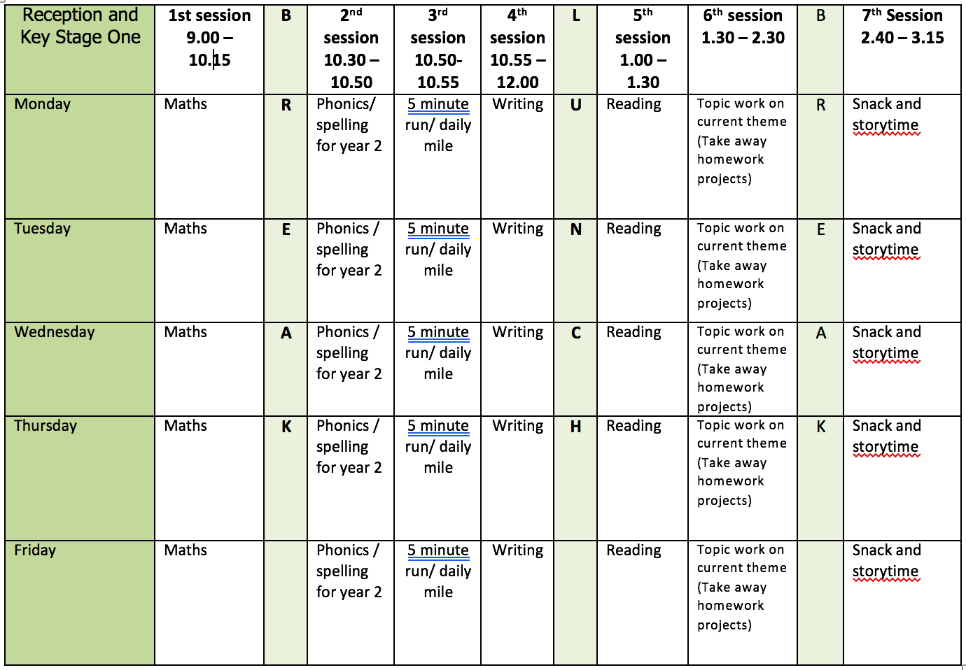

Mental health and well being

Find a quiet place to stand where you feel safe. Strike your best superhero pose and hold it for 2 minutes.
How has it made you feel?
What did your superhero smell?
What did your superhero hear?
What did your superhero see?
What did your superhero taste?
What did your superhero touch?

English

This week we will be using the book ‘Somebody Swallowed Stanley’ by Sarah Roberts as a stimulus for our writing. You can listen to the story here: https://www.youtube.com/results?search_query=somebody+swallowed+stanley

Monday: Create a poster to remind people to recycle and reuse plastic bags. You could create your poster from the point of view of Stanley and/or research facts about recycling to include on your poster.
Tuesday: recap exclamations. Complete speech bubbles for Stanley and the blue whale. What would they say to each other? You could also act this out in groups or with a family member.
Wednesday: recap exclamations. Complete speech bubbles for Stanley and the turtle. What would they say to each other? You could also act this out in groups or with a family member.
Thursday: recap exclamations. Complete speech bubbles for Stanley and the seagull What would they say to each other? You could also act this out in groups or with a family member.
Friday: recap exclamations. Complete speech bubbles for Stanley and the jellyfish. What would they say to each other? You could also act this out in groups or with a family member.

Reading

During the academic year, I compile a reading list of books that I want to read and enjoy during the summer weeks holidays. The list mostly includes new books but sometimes books I want to reread. This week I would like you to do the same – create a list of 10 books you’d like to read over the summer holidays. Try to include fiction, non-fiction and poetry. You could also include books linked to your learning in Year 2.

Phonics

Children need to do a combination of reading and writing from the word lists. I have also included some alien/nonsense words. If possible ask your child to write a sentence containing a word with that days sound in. You can make the sentence as silly as you like!

Use the week use phonic play to recap sounds. Here are some of the resources the children enjoy most in the classroom:

You can access phonics play here: https://www.phonicsplay.co.uk/ and enter the login details provided on the homepage.

https://www.phonicsplay.co.uk/resources/phase/2/dragons-den (select phase 5 sounds)

https://www.phonicsplay.co.uk/resources/phase/2/picnic-on-pluto (select phase 5 sounds)

https://www.phonicsplay.co.uk/resources/phase/2/flashcards-speed-trials (select phase 5a)

https://www.phonicsplay.co.uk/resources/phase/2/tricky-word-trucks (select any phase)

Video Links

Recapping set 2 sounds - https://www.youtube.com/watch?v=p7hRbrpq5Bo
Recapping set 3 sounds - https://www.youtube.com/watch?v=zMSvBplxgfo
Parent help video - https://www.youtube.com/watch?v=dftlTCNWlMQ

Maths

Monday: White Rose lesson one
Tuesday: White Rose lesson two
Wednesday: White Rose lesson three
Thursday: White Rose lesson four
Friday: On the very first day of year 1 we made and buried a time capsule. As part of this, we measured and cut a piece of string to our height. I’d like you to repeat this and cut a piece of string to your current height. Compare the pieces of string. How much have you grown? Can you use a non-standard unit of measure to measure both lengths and work out the difference? Please contact me and I can leave your time capsule at the front of school for collection.

The White Rose lesson resources are downloadable from the ‘Y1 home learning’ page along with video links to support each lesson.

Topic work

Monday: Use water colours and pastels to colour your recycling poster.

For the rest of the week we are going to be painting a jellyfish like the ones below. I have broken the project down into little steps for each day.
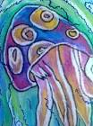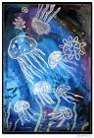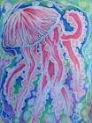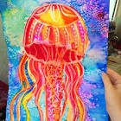

Tuesday: Look at images of jellyfish and draw it out lightly with a pencil. Go over every line of the jellyfish with a wax candle. Press hard and make the lines thick to resist the water colours. Perhaps have a look at a tutorial on you tube to help you.
Wednesday: talk about hot and cold colours and create a list. Paint the jellyfish using hot colours. Show how to mix colours so they merge.
Thursday: Recap hot and cold colours. Paint the back ground using cold colours. Show how to mix colours so they merge. Add salt for texture
Friday: mix pva glue and water together to create a wash. Cover your painting with this wash. It will give your painting a professional finish once dry – like a gloss!

PE

Try a new physical activity and learn a new skill. Could be hula hooping on one arm, skipping whilst crossing the rope, taking a penalty blindfolded etc.

