Week beginning: 29th June

Weekly timetable

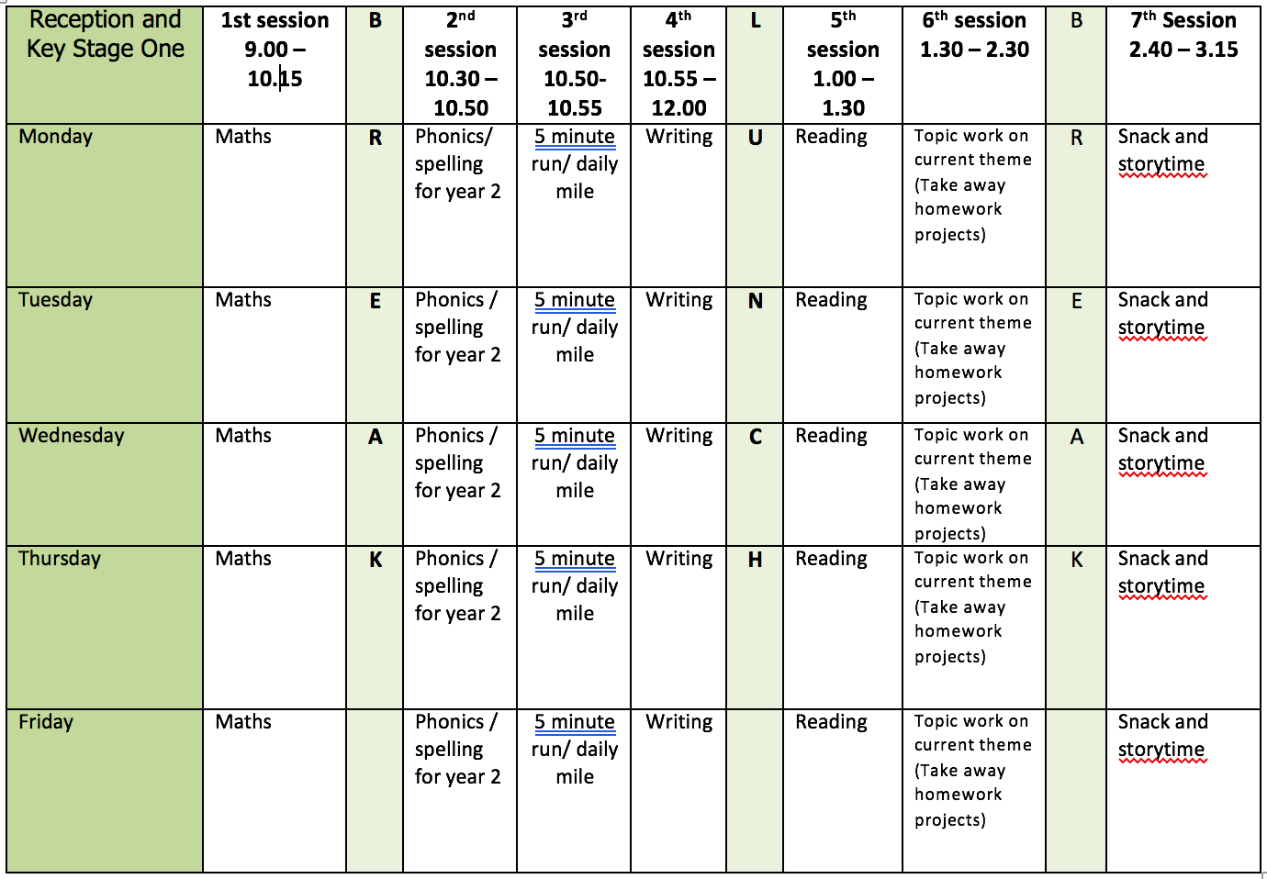

Mental health and well being

10 minutes of gratitude

This is a very quick daily exercise. It can be a good idea to do it first thing in the morning or last thing at night. In that way the grateful thoughts are more easily imprinted on the unconscious. Bring to mind 10 things which you appreciate in your life today, counting them on your fingers. It’s important to get to 10 things, even when over time it becomes increasingly hard! This is exactly what the exercise is about – consciously bringing into your awareness the previously unnoticed elements in your day to day life. Because your mind can only think of one thing at once focusing on the good aspects of your life means you’re unable to focus on anything that may be not quite as good.
English

This week we will be using the book ‘Big Blue Whale‘ by Nicola Davies as a stimulus for our writing. You will be writing your own information text about blue whales. You can listen to the story here: https://www.youtube.com/watch?v=7ly6qU7k0Mg

Monday: Read to the end of the book. Recap toolkit for information text – title/heading (written as questions)/facts/technical words/wow facts. Focus on technical words. Create a list together and model writing a definition Children to create a list with definitions which they can refer to when writing. Encourage the use of phonics to sound out words.
Tuesday: Focus on headings from toolkit. What do whales look like? What do whales eat? Talk about the use of question mark. Give children facts to sort under each heading.
How many technical words can they spot?
Wednesday: Recap facts for ‘what do whales look like?’ How many can the children remember? Create a list. Children to turn ideas into a short paragraph. Remember to include full stops and capital letters. How many technical words can you include?
Thursday: Recap facts for ‘what do whales eat?’ How many can the children remember? Create a list. Children to turn ideas into a short paragraph. Remember to include full stops and capital letters. How many technical words can you include? Can you use ‘and’ to join ideas and facts?
Friday: Share some additional facts about blue whales and ask children to chose one as their ‘wow’ fact to end their information text. Children to draw and label a blue whale using technical words.

Reading

Monday: Fluency and expression: reading out loud to develop reading fluency and expression. Continue this daily throughout the week with a range of different books.
Tuesday: Word Recognition: practice reading the tricky words from the year 1 list.
Wednesday: Make a list of 5 nouns and 5 adjectives you have read in a text you have read this week.
Thursday: Draw a picture of your favourite part of a story you have read this week. Describe what you have drawn.
Friday: ask a family member to choose a book for you to read. Read it together.

Phonics

Children need to do a combination of reading and writing from the word lists. I have also included some alien/nonsense words. If possible ask your child to write a sentence containing a word with that days sound in. You can make the sentence as silly as you like!

Use the week use phonic play to recap sounds. Here are some of the resources the children enjoy most in the classroom:

You can access phonics play here: https://www.phonicsplay.co.uk/ and enter the login details provided on the homepage.

https://www.phonicsplay.co.uk/resources/phase/2/dragons-den (select phase 5 sounds)

https://www.phonicsplay.co.uk/resources/phase/2/picnic-on-pluto (select phase 5 sounds)

https://www.phonicsplay.co.uk/resources/phase/2/flashcards-speed-trials (select phase 5a)

https://www.phonicsplay.co.uk/resources/phase/2/tricky-word-trucks (select any phase)

Video Links

Recapping set 2 sounds - https://www.youtube.com/watch?v=p7hRbrpq5Bo
Recapping set 3 sounds - https://www.youtube.com/watch?v=zMSvBplxgfo
Parent help video - https://www.youtube.com/watch?v=dftlTCNWlMQ

Maths

Monday: White Rose lesson one – ordering numbers
Tuesday: White Rose lesson two – recognising coins
Wednesday: White Rose lesson three – recognising notes
Thursday: White Rose lesson four – counting coins
Friday: Money challenges

The White Rose lesson resources are downloadable from the ‘Y1 home learning’ page along with video links to support each lesson.

Topic work

Monday: Blubber experiment! Questions to discuss – what is blubber? How does blubber keep animals such as blue whales warm? Do all whales have the same amount of blubber? Follow this link for instructions on to do carry out the experiment: https://littlebinsforlittlehands.com/blubber-experiment/
Tuesday: In which oceans will you find blue whales? Recap continents and oceans and draw a map. Use our favourite song to recap… https://www.youtube.com/watch?v=K6DSMZ8b3LE
Wednesday: Use water colours to paint the continents and oceans.
Thursday: Introduce different kinds of whales and which oceans they can be found. Label map and create a key with up to 3 different whales and the oceans/continents they can be found.
Friday: Make a whale peg puppet.
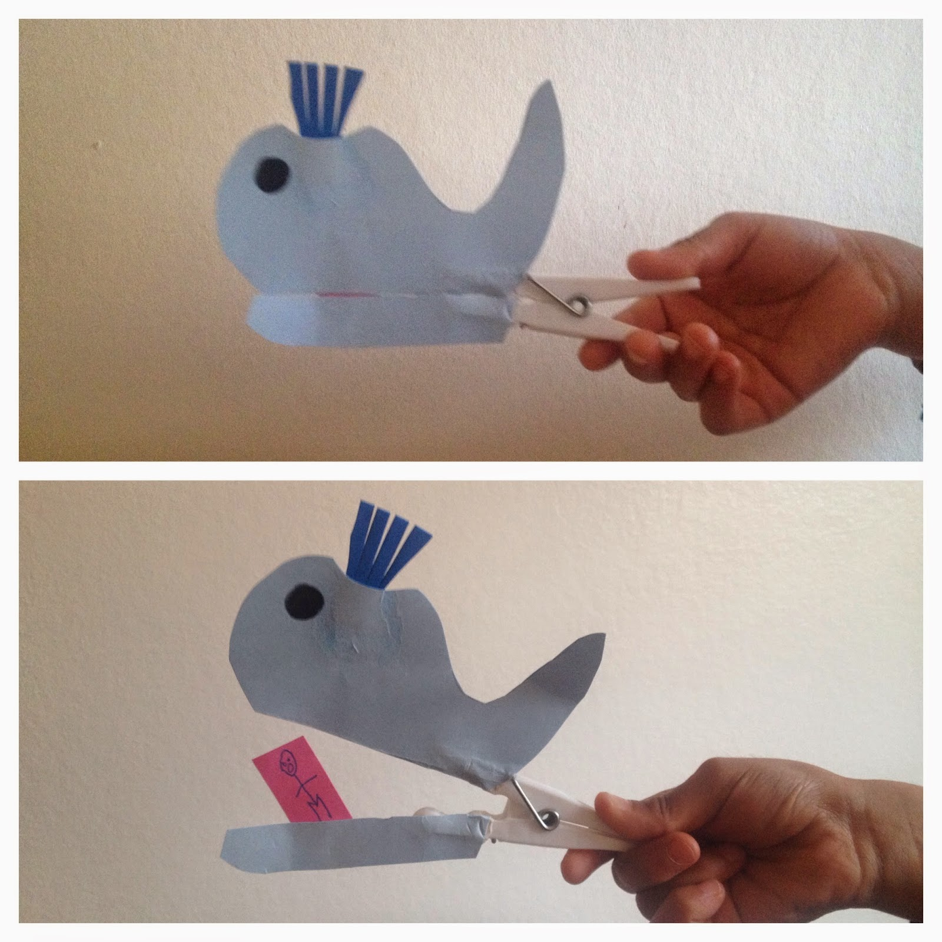

PE

Mr Dooley’s activities which can be downloaded from this week’s home learning page.

