Week beginning: 21st June

Weekly timetable

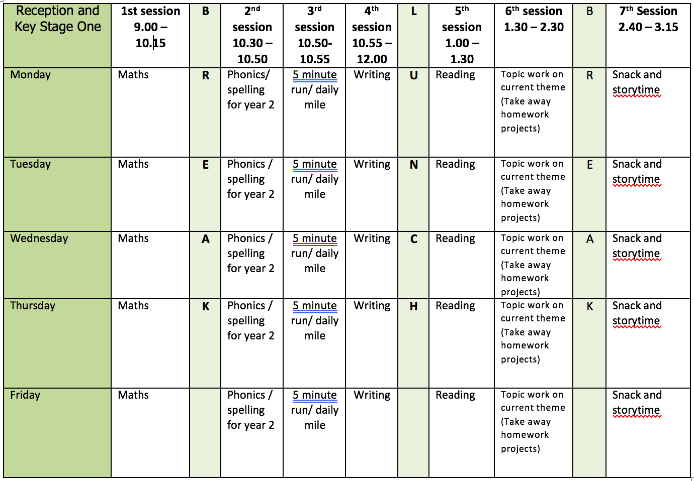

Mental health and well being

Go on a walk. While you are out, look around and take in your surroundings. Can you list 5 things you can see, 4 things you can touch, 3 things you can hear, 2 things you can smell and 1 thing you can taste.

English

This week we will be using the book ‘Big Blue Whale‘ by Nicola Davies as a stimulus for our writing. You can listen to the story here: https://www.youtube.com/watch?v=7ly6qU7k0Mg

Monday: How big do we think a whale is? Is it bigger than a dinosaur? Read the page 6.
Go onto the playground and measure 30 metres. Compare this to other animals mentioned in the text by measuring them as well.
Blue whale – 30 metres
African elephant – 4 metres
Giraffe – up to 6 metres
Diplodocus – 26m
Write sentences describing the size of a blue whale. E.g. Blue whales are bigger than an elephant.
Tuesday: Read pages 8-10 of ‘Big blue whale.’ Look at the figurative language describing the whale ‘blue whale’s skin. It’s springy and hard like a boiled egg and as slippery as wet soap,’ ‘Look into its eye. It’s as big as a teacup and as dark as the deep sea.’
Watch videos about whales. How do they move? Brainstorm verbs for the way they move and adjectives to describe the whales.

Video links

https://www.youtube.com/watch?v=1fzT6ifrhL8
https://www.youtube.com/watch?v=9pjI2XkmoL0
https://www.youtube.com/watch?v=LajBrMPY1jU

Wednesday: Recap vocab collected yesterday. Share poem by Gina Douthwaite ‘Captivating Creature.’ Shared writing - changing and writing poem so it is describing a whale. E.g Whale swimming swiftly at sea Using her tail to toss the waves high.
Thursday: Learn poem written yesterday about Blue Whales and perform it. Could you add actions?
Friday: Read pages 10-17 about what whales eat. Recap toolkit for information text – title/heading (written as questions)/facts/technical words/wow facts. Focus on technical words. Create a list together and model writing a definition Children to create a list with definitions which they can refer to when writing. Encourage the use of phonics to sound out words.

Reading

Monday: read your favourite book outside.
Tuesday: read a book you have not read before. Write a book review.
Wednesday: Listen to ‘chocolate cake’ by Micheal Rosen. You can listen by following this link https://www.youtube.com/watch?v=7BxQLITdOOc
Discuss the poem and write/draw your favourite part. My favourite part is when Micheal sneaks down to eat the cake!
Thursday: read a non-fiction book about a sea creature. Discover a new word and write it in a sentence. Can you draw a picture to show the words meaning?
Friday: set up a video call with a family member you do not live with. Read a story to them or ask them to read to you. Enjoy the book together and talk about it.

Phonics

Children need to do a combination of reading and writing from the word lists. I have also included some alien/nonsense words. If possible ask your child to write a sentence containing a word with that days sound in. You can make the sentence as silly as you like!

Monday: ‘ai’ sound (snail in the rain)
Word list: claim/stain/plain/paint/explain/flait/straip
Tuesday: ‘oa’ sound (goat in a boat)
Word list: throat/cockroach/float/roast/toast/approach/doaf/groad
Wednesday: ‘ew’ sound (chew the stew)
Word list: nephew/curfew/few/knew/crew/glewt/newt
Thursday: ‘ire’ sound (fire, fire!)
Word list: fire/wire/hire/conspire/vampire/admire/spire/quire
Friday: Dice spellings from year 1 list. How to play:
- Choice a word from the year one list. This can be downloaded from the ‘y1 home learning’ page.
- Read it, look at it and spell out loud.
- Roll a dice and check the list below to see what you need to do. The word should be written three times or set a timer.
1 – write the word in your smallest writing
2- write the word in all capital letters
3- write the word with your other hand (e.g. write with your right hand if you are left handed)
4 – write the word in curly fancy writing
5 – write the word with your eyes closed
6 – draw a picture of the word

Video Links

Recapping set 2 sounds - https://www.youtube.com/watch?v=p7hRbrpq5Bo
Recapping set 3 sounds - https://www.youtube.com/watch?v=zMSvBplxgfo
Parent help video - https://www.youtube.com/watch?v=dftlTCNWlMQ

Maths

Monday: White Rose lesson one – counting to 100
Tuesday: White Rose lesson two – partitioning numbers
Wednesday: White Rose lesson three – comparing numbers
Thursday: White Rose lesson four – comparing numbers
Friday: number square puzzles https://nrich.maths.org/5572

The White Rose lesson resources are downloadable from the ‘Y1 home learning’ page along with video links to support each lesson.

Topic work

Monday: create a name card for your desk/home learning space/bedroom door.
Tuesday: Look at images of Blue Whales and draw an outline. Fill your whale with patterns using dots and lines. Use sharpie pen to do this.


Wednesday: Use blue ink/paint/water colours to give your whale a wash of colour.
Thursday: Use different shades of blue, grey, and purple pastels to highlight some of the patterns on your whale.
Friday: Make an origami whale. https://www.youtube.com/watch?v=kOm47eh2AYk

PE

Mr Dooley’s activities which can be downloaded from this week’s home learning page.

