Spirit
By Sally Christie
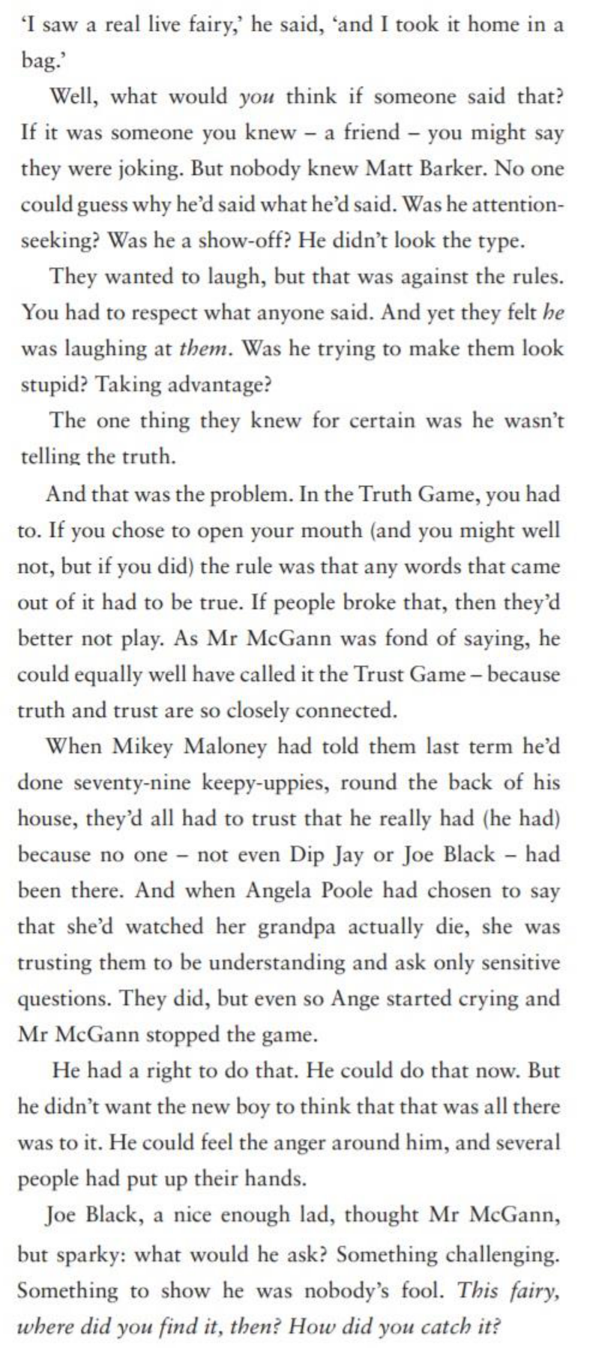

Retrieval questions

1 . Who was Matt Barker?

2. What had Mikey Maloney told them last term?

3 . Who asked the first question?

Inference questions

1 . Who do you think Mr McGann is? Support your answer with evidence from the text.

2. Why do you think Mr McGann said that truth and trust were closely connected?

3 . How do you know the ‘Truth Game’ had been played before?

4 . Are Mikey Maloney and Joe Black friends? Support your answer with evidence from the text.

5 . How old do you think Mikey Maloney is? Support your answer with evidence from the text.

Choice questions

1 . Mr McGann describes Joe Black as ‘sparky’ what do you think this means?

2. Why is the word ‘he’ and ‘them’ in an italic font?

Challenge question

What do you think will happen next in the story?

