William Wenton and the Secret Portal
by Bobby Peers
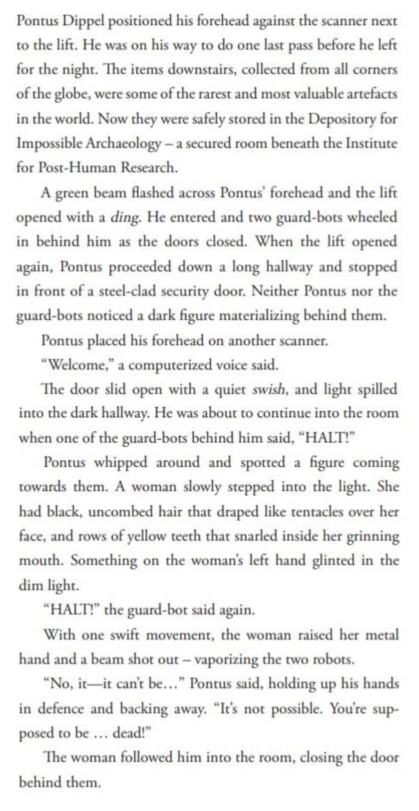

Words in Context

Find and highlight the following words in the text.

- Artefacts

- Materializing

- Proceeded

What do you think they mean? What word or phrase could you replace them with? .

Retrieval questions

1 . Where is Pontus?

2. Where is the Depository for Impossible Archaeology?

3 . How does the author describe the woman’s hair? .

Inference questions

1 . What do you think Pontus Dippel's job was? Support your answer with evidence from the text.

2. Find three pieces of evidence which suggests this a fantasy story .

3 . What do you think the name ‘Post -human’ suggests about the story?

4 . What do you think the guard bots look like? Support your answer with evidence from the text.

Choice questions

1 . What word in the text mean ‘turned quickly’ .

2. Why is the word ‘swish’ in an italic font?

Challenge question

Who do you think the woman is and how do you think Pontus Dippel knows her?

