Week beginning: 15th June

Weekly timetable

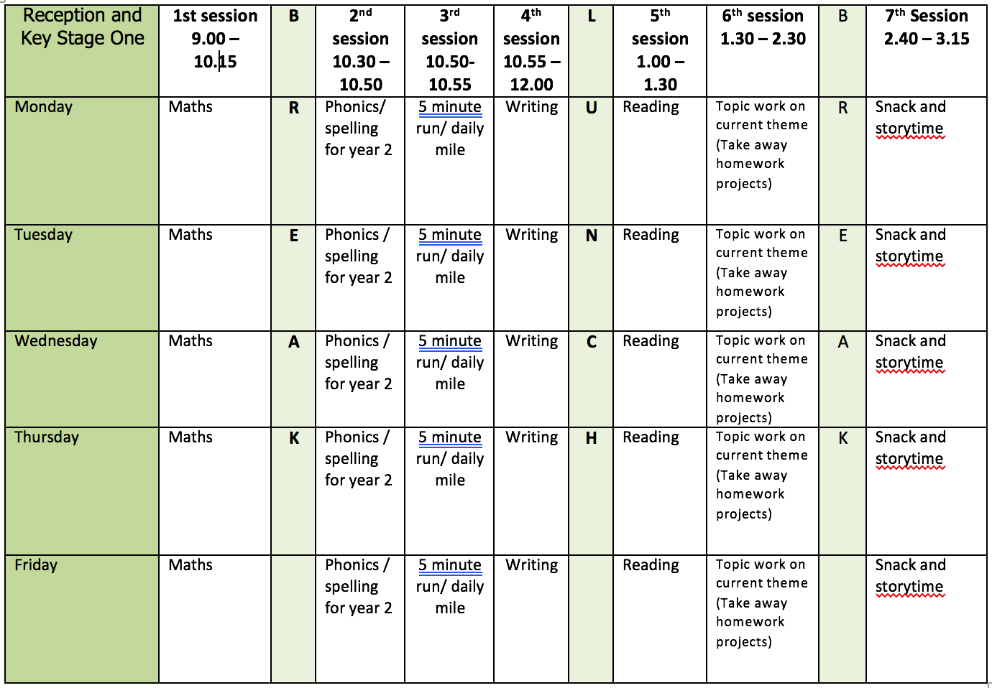

Mental health and well being

Go on a walk. While you are out, look around and take in your surroundings. Can you list 5 things you can see, 4 things you can touch, 3 things you can hear, 2 things you can smell and 1 thing you can taste.

English

This week learning remains in Bottlenose Bay but this time with a very sneaky character called Light Fingered Larry! You can download a PowerPoint of this story from the ‘Y1 home learning’ page for this week.

Monday: Read the first page of the story and stop at ‘… surrounded by stolen treasure.’ Write a description of Light Fingered Larry. What does he look like? How does he move? What does he do? E.g. Light Fingered Larry is an octopus who always causes mischief. He is orange and all eight tentacles are covered in dark red spots. Watch out! Etc.
Tuesday: Continue reading and stop at ‘As slippery as you like, those sly tentacles took things and stashed them away.’ Write a letter to Officer Pavani (the police officer in Bottlenose Bay) to explain what Light Fingered Larry is doing and what he has stolen. Look closely at the images in the book to see what has been stolen!
Wednesday: Continue reading and stop at ‘… and Kiki worked hard to make everybody happy.’. Create a menu for ‘The Jolly Tugboat’. What would you serve? What do you think the residents of Bottlenose Bay would like to eat? Use adjectives to describe the dishes you choose e.g. Crispy cod and salty chips/warm gooey chocolate pudding served with juicy raspberry sauce.
Thursday: Continue reading and stop at ‘he felt very sorry for what he’d done’. Have a look at all the items in Larry’s net, create a list of the items using noun phrases to describe them. E.g. red reading glasses, purple purse, bright yellow corn on the cob etc.
Friday: Read to the end of the story. Create a wanted poster for Officer Pavani’s missing keys. Draw a picture, describe what they look like and offer a reward if found. A template for this poster can be downloaded from this weeks home learning page.

Reading

Light Fingered Larry is an octopus! I know how much the children love facts and animals so our reading this week will focus on finding out about octopuses.

Monday – Checking it makes sense: Read the ‘Octopus Facts’ together which can be downloaded from this weeks home learning page. As you read circle any new words or words that you are unsure of the meaning. Discuss these words together.
Children are likely to need support reading this and I have purposely included some tricky words to develop vocab. One approach when reading could be to take it in turns to read a sentence each.
Tuesday – Extracting Vocabulary – Using the words circled yesterday from the text, ask the children to write/say sentences containing them, showing their understanding.
Wednesday – Answering questions: Re-read the ‘Octopus Facts’ and answer the questions. What do octopuses eat? What colour is their blood? How many hearts do octopuses have? When do octopuses hunt for food?
Thursday - Features of non-fiction texts: Talk about fiction and non-fiction texts. What is the same? What is different? You could have an example of each to aid this discussion. Talk about the use of labelled diagrams in non-fiction texts. Can you draw and label an octopus?
Friday – Retelling: Share all you have learnt about octopuses with a family member. This could be through a letter or a phone call or a quiz. Share a new word you have learnt and explain what it means also.

Phonics

Children need to do a combination of reading and writing from the word lists. I have also included some alien/nonsense words. If possible ask your child to write a sentence containing a word with that days sound in. You can make the sentence as silly as you like!

Monday: ‘are’ sound (care and share)
Word list: Bare/glare/spare/scare/share/splare/quare
Tuesday: ‘ur’ sound (nurse with a purse)
Word list: slur/church/turnip/disturb/Thursday/zurb/nur
Wednesday: ‘er’ sound (better letter)
Word list: burger/lighter/sharper/whisper/herb/herks/versp
Thursday: ‘ow’ sound (brown cow)
Word list: down/brown/crowd/growl/gown/shower/gunpowder/flower/glowd/frowt
Friday: Dice spellings from year 1 list. How to play:
- Choice a word from the year one list. This can be downloaded from the ‘y1 home learning’ page.
- Read it, look at it and spell out loud.
- Roll a dice and check the list below to see what you need to do. The word should be written three times or set a timer.
1 – write the word in your smallest writing
2- write the word in all capital letters
3- write the word with your other hand (e.g. write with your right hand if you are left handed)
4 – write the word in curly fancy writing
5 – write the word with your eyes closed
6 – draw a picture of the word

Video Links

Recapping set 2 sounds - https://www.youtube.com/watch?v=p7hRbrpq5Bo
Recapping set 3 sounds - https://www.youtube.com/watch?v=zMSvBplxgfo
Parent help video - https://www.youtube.com/watch?v=dftlTCNWlMQ

Maths

I recommend that children have counters to support their learning this week.

Monday: White Rose lesson one - arrays
Tuesday: White Rose lesson two – doubles
Wednesday: White Rose lesson three – sharing
Thursday: White Rose lesson four – grouping
Friday: Willy and Wendy Worm.

The White Rose lesson resources are downloadable from the ‘Y1 home learning’ page along with video links to support each lesson.

Topic work

Monday: Make your own Light Fingered Larry puppet. Watch this video for how to do it: https://www.youtube.com/watch?v=qR7m46GHpSo All you need is an old sock, elastic band, google eyes and some rice (this will work just the same as polyfill).
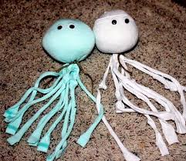

Tuesday and Wednesday: Light Fingered Larry stole the Pond Children’s jam tarts. Follow the recipe to make jam tarts so they can be replaced. Recipe: https://www.bbcgoodfood.com/recipes/valentines-day-jam-tarts
Write instructions of how to make jam tarts. You could take photos of each stage whilst baking to help you write your instructions.

Thursday: Create a catapult (which we can imagine fires a net!) to capture Light Fingered Larry. Place your Light Fingered Larry sock puppet somewhere and fire a foil ball in his direction. If it hits Light Fingered Larry you have successfully captured him! You could also measure how far the foil ball goes. Here are some ideas and video links for a catapult:

Images

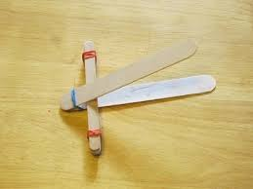
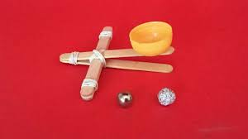
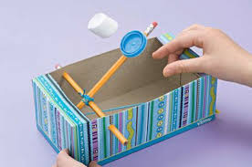

Video Links

Lollipop stick catapult: https://www.youtube.com/watch?v=qR7m46GHpSo
Pencil catapult: https://www.youtube.com/watch?v=vTl1T8Fkj8A

Friday: Paint/draw a picture of Light Fingered Larry in his underwater den. What treasures do you think he was surrounded by? Add these to your drawing/painting as well.

PE

Mr Dooley’s virtual sports day activities.

