Week beginning: 8th June

Weekly timetable

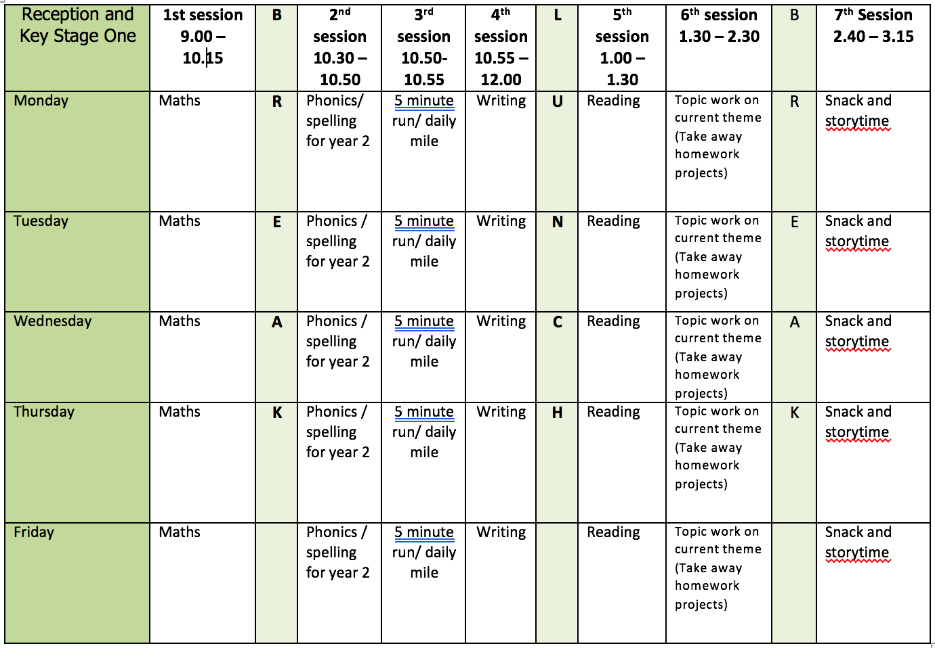

Mental health and well being
Sometimes we have big feelings. Your mind may be feeling all swirly and mixed up because you are mad, angry, confused, sad or something else. It is ok to feel this way. When you have these feelings, you can take a little break with your glitter jar. Just like your big feelings, shake up your glitter jar and watch it swirl all over like crazy. Then set the jar down, watch it swirl and breathe. As you breathe and are still the glitter starts to slowly settle and become calmer. Watch until you can see through the jar again.
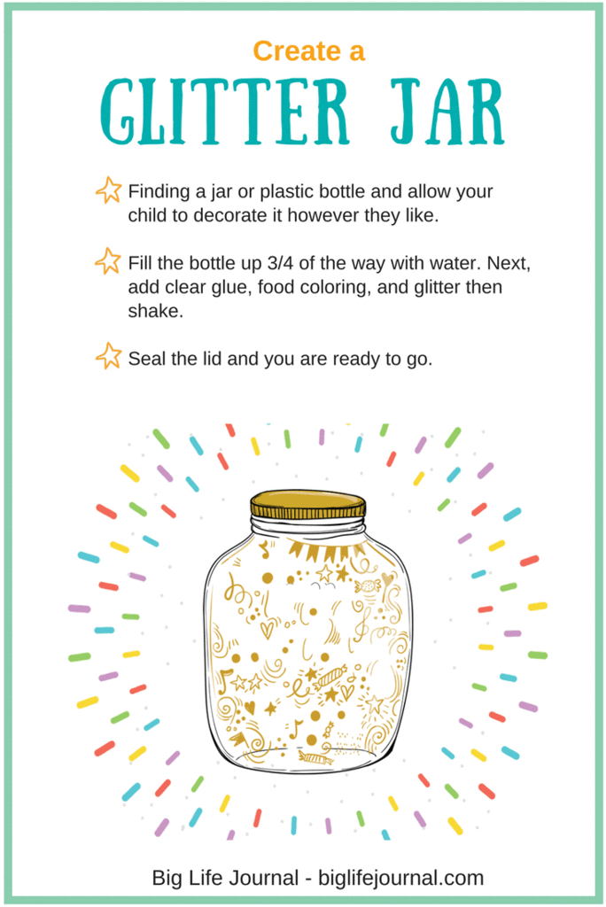

English

This week we will be continuing to use ‘Harry and the Jaggedy Daggers’ by Jan Fearnley. The book is available to listen to on YouTube – click the link below.
https://www.youtube.com/watch?v=LhTSQZjwq8s

Last week we ended the story when the storyteller said ‘’But as well as mischief, the wind and the sea can bring surprises and treasures too.” I would recommend starting the week by recapping the story so far.

Monday: Listen to the story and pause when the storyteller says, ‘what a silly thing! scoffed the river rats.’ Can you write a description of Harry’s new boat? E.g. The teacup was white and covered in royal blue stars. It was a little chipped, but Harry did not mind. He knew how damaging the sea could be. Etc.
Tuesday: Listen to the story and pause when the storyteller says, ‘It was true, the teacup boat was very small.’ Have a look at the image of The Pond Children inside the teacup. Can you write some speech bubbles for the frogs? What do you think they are saying to each other? Challenge – could you include a question mark or an exclamation mark. E.g. Are we nearly there? Or Woah! That was a big wave.
I have uploaded an image of this page which you can download from the ‘y1 home learning’ page so you can get a close look at the frogs.
Wednesday: Listen to the story and pause when the storyteller says, ‘The wind howled and whistled’. Write a description of the storm. Describe the waves, the sky and the sounds. E.g. The sky over Bottlenose Bay was dark and the clouds were full of rain. The waves were as big as a house and Harry felt a little seasick.
Thursday: Listen to the story and pause when the storyteller says, ‘Only Harry, in his tiny boat, could save the eggs now’. What do you think Harry will do next? How do you think he will save the eggs? Act it out and create a freeze frame. Draw and label a picture of how you think Harry will save the eggs. Complete the sentence… ‘Harry will save the eggs by…’
Friday: Listen to the end of the story. Write a letter to Harry to say thank you and explaining why you think he is a hero.

Reading

Monday: Read a non-fiction book (a different one to last week!). Pick 3 ‘technical words’ and create an illustrated glossary to show their meaning.
Tuesday: Read a book you have not read for a long time.
Wednesday: Wacky Wednesday by Dr Suess is one of my favourite books. I love taking a pause from reading and searching the images for the wacky things! Listen to the story and pause on each page whilst you search for the wacky things. Create a list of the top three wackiest things you found! Here is a link to the story:
https://www.youtube.com/watch?v=b653k3-_wIM
Thursday: Find a comfy spot in your house, choose a book and take it in turns to read a page with Mum, Dad, brother or sister. Discuss the story as you go and make predictions.
Friday: Think about your favourite character from a book. Can you describe them? What do they look like? How do they act in the story? Write 3 questions that you would like to ask this character if you were to meet them.

Phonics

Children need to do a combination of reading and writing from the word lists. I have also included some alien/nonsense words. If possible ask your child to write a sentence containing a word with that days sound in. You can make the sentence as silly as you like!

Monday: ‘o-e’ sound (phone home) split digraph. Word list: Stroke/rose/slope/quote/compose/microscope/remote/snofe/shobe
Tuesday: ‘u-e’ sound (huge brute) split digraph – can be pronounced ‘you’ or ‘oo’
Word list: Cube/tube/perfume/confuse/acute//thrupe/flute
Wednesday: ‘aw’ (yawn at dawn) Word list:
Straw/drawn/prawn/squawk/raw/claw/awful/blaw/scraw
Thursday: Recapping all the split diagraphs – ‘a-e’ ‘i-e’ ‘o-e’ and ‘u-e’ through ‘the floor is lava’ game. Thank you to the Morrisroe’s for this idea!
Download the split digraph word list from the ‘y1 home learning’ page.
Scatter the words out on the floor and explain the carpet is lava and the words are stepping stones – only the stepping stones are safe to land on. Call out a split diagraph and you must hop around the words (avoiding the floor) until you find a word containing the split diagraph called. Once a word is found, read it out loud.
Friday: Dice spellings from year 1 list. How to play:
- Choice a word from the year one list. This can be downloaded from the ‘y1 home learning’ page.
- Read it, look at it and spell out loud.
- Roll a dice and check the list below to see what you need to do. The word should be written three times or set a timer.
1 – write the word in your smallest writing
2- write the word in all capital letters
3- write the word with your other hand (e.g. write with your right hand if you are left handed)
4 – write the word in curly fancy writing
5 – write the word with your eyes closed
6 – draw a picture of the word

Video Links

Recapping set 2 sounds - https://www.youtube.com/watch?v=p7hRbrpq5Bo
Recapping set 3 sounds - https://www.youtube.com/watch?v=zMSvBplxgfo
Parent help video - https://www.youtube.com/watch?v=dftlTCNWlMQ

Maths

I recommend that the children have practical resources (counters/numicon) to support their learning this week.

Monday: White Rose lesson one - counting in 2s
Tuesday: White Rose lesson two – counting in 5s
Wednesday: White Rose lesson three – counting in 10s
Thursday: White Rose lesson four – adding equal groups
Friday: Challenge questions linked to learning throughout the week. This can be downloaded from the ‘year 1 home learning’ page. I recommend that the children have practical resources (counters or numicon) to help them solve the problems and explain/show their thinking.

The White Rose lesson resources are downloadable from the ‘Y1 home learning’ page along with video links to support each lesson.

Topic work

Topic work for this week will link to the story ‘Harry and the Jaggedy Daggers’ that we are using as a stimulus for our writing.

Monday: Harry found a china teacup for his new boat. What other household items could you recycle and reuse as a boat? E.g. vase, fruit bowl, colander etc. Collect these items, create a list and test whether they float or sink. Show your findings in a table. Which item do you think would make the best boat?
Tuesday: Harry took the pond children to school in his teacup boat and it nearly capsized! How many frogs does it take to capsize a teacup? You might have to improvise here with the teacup and frogs – in school I am going to use a muller yoghurt pot and some counters to represent the frogs.
Wednesday: Harry sails and battles through a storm. Paint a picture of a stormy sky or create a stormy sky collage. What colours will you use? How could you represent the swirling wind?
Thursday: Samina Songbird’s eggs blew straight out of her tree and they were swept into the sea. Design and create a device that would protect the eggs from the stormy sea. Junk model materials might be best here. If you wanted to you could test your creation with a real egg and create a storm by splashing the water/hair dryer for wind etc – will your egg survive?
Friday: Today’s activity will also combine our maths learning from this week! Harry uses a spoon to scoop the eggs out of the sea and I would like you to re-create this scene.
You will need a large container of water, a spoon and ‘eggs’ (improvise here – in school I will be using ping pong balls). Once you have set up the scene you need to decide how many points each egg is worth (2 points, 5 points or 10 points). Now set a timer – perhaps start with 60 seconds and reduce the time as you go to make it harder! How many eggs can you save from the sea using the spoon? Count your total by counting in multiples of 2s, 5s or 10s. You could make this game harder by asking an adult or sibling to move the container of water as you play to recreate the storm.

PE

- Use the links and resources from Mr Dooley already available on the class home learning webpage.
- Cosmic Kids Yoga - https://www.youtube.com/user/CosmicKidsYoga
- Go noodle - https://www.youtube.com/user/GoNoodleGames

