Number Square Work
You can download a number square for this question which can be downloaded from the ‘y1 home learning’ page.

Janine is counting in 10’s on a number square.
She starts at 10.
Shade in all the numbers Janine will say.
What is the same about the numbers she says?
What is different about the numbers?

George is counting in 2’s on a number square.
He starts at 2.
Shade in all the numbers George will say.
What is the same about the numbers?
What is different about the numbers?

Maisie is counting in 5’s on a number square.
She starts at 5.
Shade in all the numbers Maisie will say.
What is the same about these numbers?
What is different about these challenges?

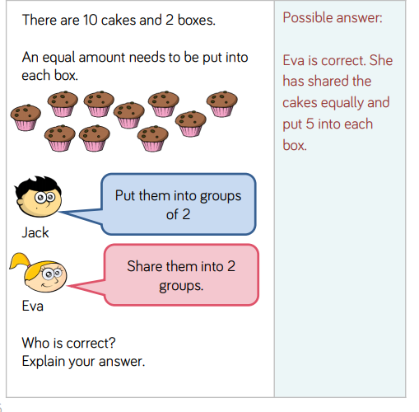
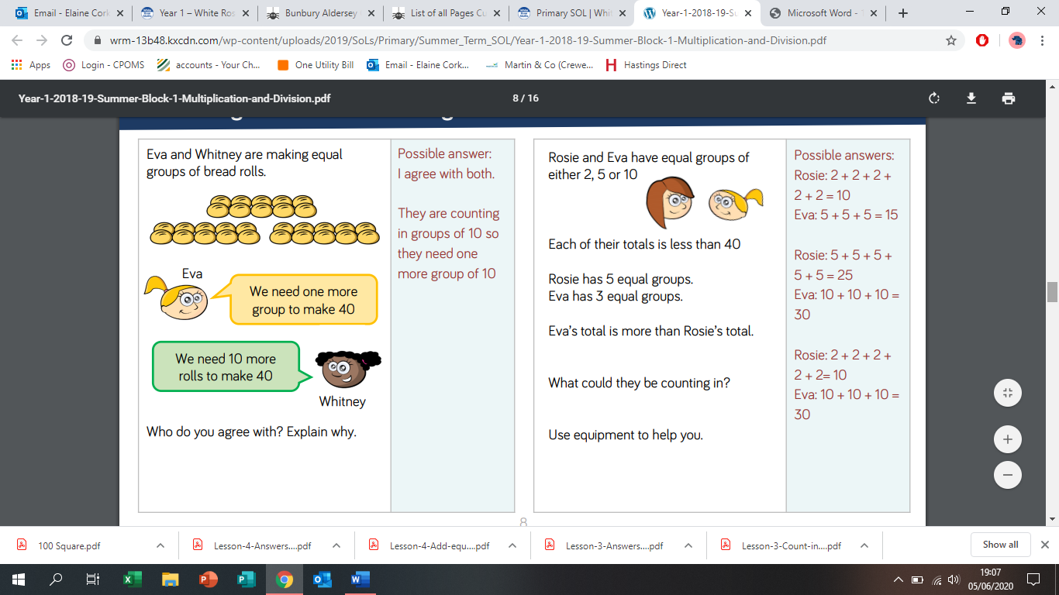
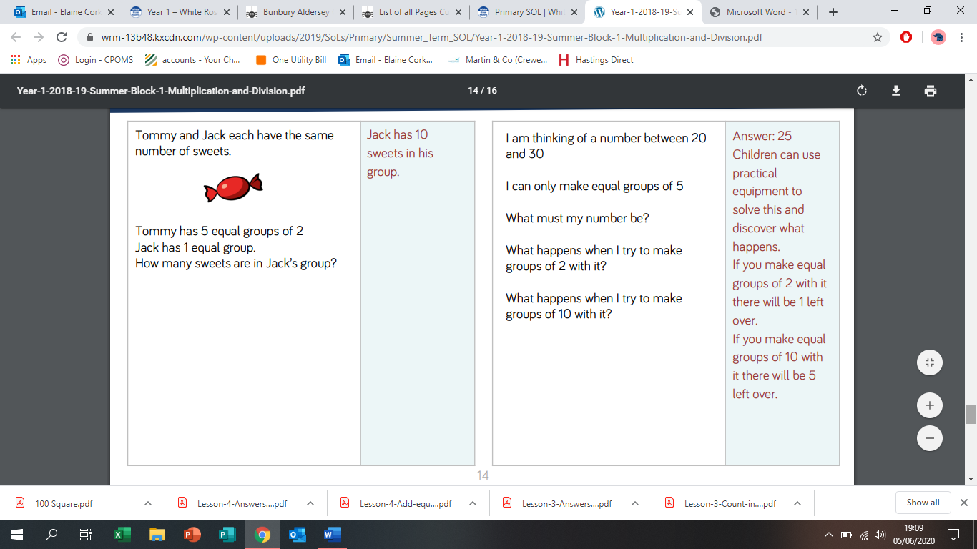
Further Challenge Questions

