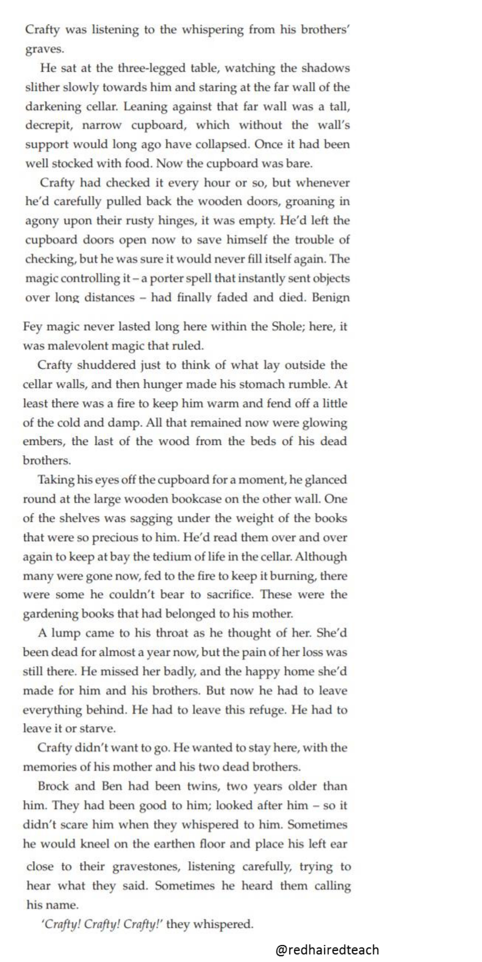
Aberrations – The Beast Awakens
by Joseph Delaney.

Words in Context

Find and highlight the following words in the text.

- Decrepit

- Benign

- Malevolent

What do you think they mean? What words could you replace them with?

Retrieval questions

1 . Where is Crafty?

2. How long had his mother been dead?

3 . Did Crafty want to leave the cellar? .

Inference questions

1 . Has Crafty been in the cellar a long time? Support your answer with evidence from the text.

2. Find three pieces of evidence which suggests this a fantasy story .

3 . Find evidence to suggest the cupboard had previously been magical ..

4 . What time of day is it? Support your answer with evidence from the text.

Choice questions

1 . What word in the text mean ‘a place of safety’ .

2. The author uses personification in the 2 ^{n d} paragraph – can you identify it? What effect does it have?
Challenge question

What effect does the first line of the extract have on the reader?

