Week beginning: 1stt June

Weekly timetable

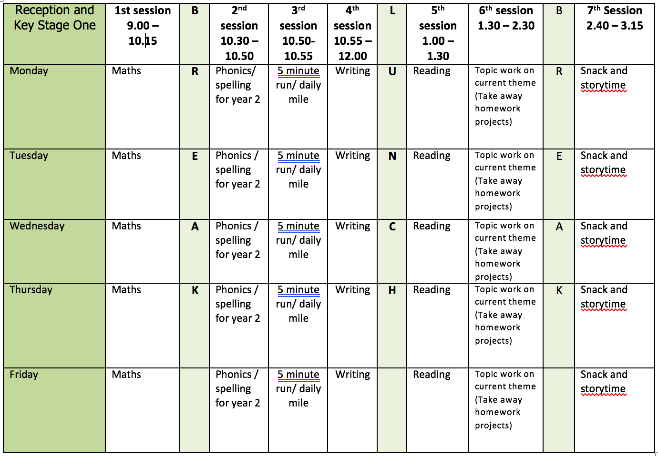

Mental health and well being

Just before bedtime take some time to reflect on the day. Write down three good things that happened or that you achieved. At the end of the week collect all the things you wrote down and reflect on your week.

English writing activities for the week:

Our writing for the next two weeks will be based around the book ‘Harry and the Jaggedy Daggers’ by Jan Fearnley. The book is available to listen to on YouTube – click the link below.
https://www.youtube.com/watch?v=LhTSQZjwq8s)

Monday: Listen to the first page on YouTube and pause the video when the story teller says ‘Bottlenose Bay’. Have a look at the image. What can you see in the image? What is happening in the image? What might you be able to hear? What is the weather like? Create a list of all your ideas.
Tuesday: Listen to the first page on YouTube and pause the video when the story teller says ‘Bottlenose Bay’. Remind yourself of the list you created yesterday describing Bottlenose Bay. Use those ideas to write some sentences to describe Bottlenose Bay – remember to include full stops, capital letters and finger spaces. E.g. There were many boats floating on the water of Bottlenose Bay. Some were small, some were big and some even had spotty sails. Etc.
Wednesday: Carry on watching the video and perhaps pause to talk about the meaning of the words ‘cargo’ and ‘mischief’. Pause the video again when the storyteller says ‘crunched that poor boat up’. Look at the image of the jaggedy daggers. What do they look like? What would they feel like? Look closely… describe their teeth! Create a list of words to describe the jaggedy daggers.
Thursday: Watch the video again up to the same point as yesterday to remind you of the story so far. Remind yourself of the list of words you created yesterday describing the jaggedy daggers. Write some sentences using these ideas to describe the jaggedy daggers. E.g. The jaggedy daggers are dangerous sharp rocks that live just below the surface of the water. Their teeth are razor sharp and always hungry.
Friday: Carry on listening to the story and pause the video when the storyteller says, ‘surprises and treasures too’. What surprises and treasures do you think the sea can bring? Draw and label a picture of these treasures and surprises. What might Harry be hoping for?

Reading

Monday: Read your favourite book in your favourite place!
Tuesday: Read a book you have never read before. Are there any new words? Are there any words that you did not know the meaning of? Talk to an adult about these new words – can you write a sentence using them?
Wednesday: Read a non-fiction book. What did you learn? Write down 3 facts and share them with somebody in your family.
Thursday: Listen to ‘The Ning Nang Nong’ by Spike Milligan. This is my favourite poem – it is so silly! https://www.youtube.com/watch?v=0Wom1OzwzLw
https://www.youtube.com/watch?v=yD-yG2XnxpU
Make a list of all the words that rhyme with ning, nang, nong.
Friday: Write a book review about your favourite book. Why do you like it? Where is it set? Who are the characters? Share your book review with a friend who might also like this book.

Phonics

Children need to do a combination of reading and writing from the word lists. I have also included some alien/nonsense words. If possible ask your child to write a sentence containing a word with that days sound in. You can make the sentence as silly as you like!
Monday: ‘ea’ sound (cup of tea)

reach/deal/scream/wheat/please/feast/increase/season/yeak/threaf

Tuesday: ‘oi’ (spoil the boy)

boil/foil/moist/appoint/moisture/avoid/floib/shoit

Wednesday: ‘a-e’ (split digraph) (make a cake)

flame/game/shame/skate/taste/escape/aeroplane/calculate/ thabe/spave

Thursday: ‘i-e’ (split digraph) (nice smile)

hide/bride/kite/tribe/invite/divide/describe/bime/plime

Friday:

Dice spellings from year 1 list. How to play:
- Choice a word from the year one list. This can be downloaded from the ‘y1 home learning’ page.
- Read it, look at it and spell out loud.
- Roll a dice and check the list below to see what you need to do. The word should be written three times or set a timer.
1 – write the word in your smallest writing
2- write the word in all capital letters
3- write the word with your other hand (e.g. write with your right hand if you are left handed)
4 – write the word in curly fancy writing
5 – write the word with your eyes closed
6 – draw a picture of the word

Video Links

Recapping set 2 sounds - https://www.youtube.com/watch?v=p7hRbrpq5Bo
Recapping set 3 sounds - https://www.youtube.com/watch?v=zMSvBplxgfo
Parent help video - https://www.youtube.com/watch?v=dftlTCNWlMQ

Maths

Monday: White Rose lesson one - measuring mass
Tuesday: White Rose lesson two – comparing mass
Wednesday: White Rose lesson three – introducing capacity and volume
Thursday: White Rose lesson four – measuring capacity
Friday: Bottle Challenge 1 and bottle challenge 2. You can download these challenges from the ‘Y1 home learning’ page.

The White Rose lesson resources are downloadable from the ‘Y1 home learning’ page along with video links to support each lesson.

Topic work

Topic work for the next two weeks will link to the story ‘Harry and the Jaggedy Daggers’ that we are using as a stimulus for our writing.

Monday: Bottlenose Bay is close to a winding river. Can you build a bridge so Harry can cross the river? Test the strength of your bridge by adding coins – how many will it hold?
Tuesday: Create a map of Bottlenose Bay. Use the image of Bottlenose Bay from the first part of the story and the list you made of all the things you could see. Don’t forget to include Harry’s house and the jaggedy daggers! Use symbols and create a key.
Wednesday: Create your own jaggedy daggers. You could paint rocks you have found whilst out walking, use card, lego or you could even make biscuit jaggedy daggers!
Thursday: Design a new boat for Harry. Remember he carries lots of cargo every day so think about how the boat could carry the cargo. Draw your design, label it and create a list of all the resources you will need. What will you name the boat? Make sure it floats!
Friday: Using your design from yesterday, create/build/make your boat for Harry.

PE

- Use the links and resources from Mr Dooley already available on the class home learning webpage.
- Cosmic Kids Yoga - https://www.youtube.com/user/CosmicKidsYoga
- Go noodle - https://www.youtube.com/user/GoNoodleGames

