Y3 Autumn Term: Takeaway Homework
Option A  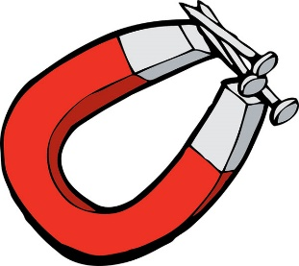  Design and carry out your own experiments using magnets. Don’t forget to record your results! | Option B  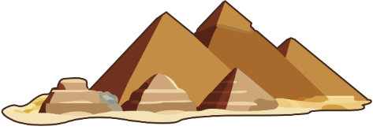  Construct and decorate a 3D model of the pyramids of ancient Egypt | Option C  Write a short about an Ancient Egyptian Pharaoh. (Maybe you could choose Tutankhamun, Nefertiti or Cleopatra)  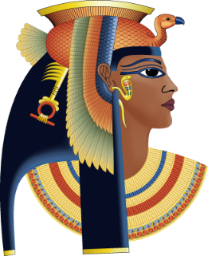
Option D  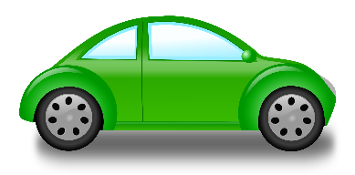  Build a vehicle of some kind that can travel (land, water, air). | Option E  Visit a river, take a picture and draw a diagram of it labelling the main features. Maybe you could record the different animal and plant species you saw on your visit.  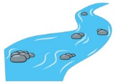 | Option F  Find or create a recipe using only ingredients that would have been available in Ancient Egypt. Bring in your recipe and photos!  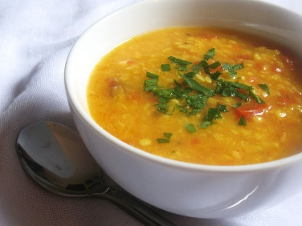
Choose one task each half term and bring your work into school on the last Wednesday of this half term for our school-wide sharing day. The whole school will do a ‘gallery walk’ into every other class and be able to see and celebrate each other’s work.

