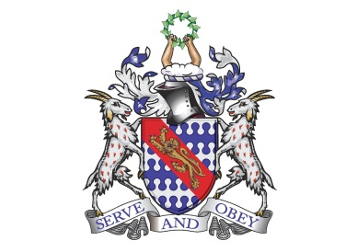

**Bunbury Aldersey CE Primary School**

**Homework – Autumn A**

High frequency word spellings to learn – these will not be tested. Weeks are there for guidance only. These words will **not** appear on the weekly spelling test (see weekly spelling homework sheet for test words) but will affect the assessment of a pupils’ writing level if they are not correct consistently.

Please note: if your child is struggling with these words, please ignore them and instead revise the year 1&2 common exception words (list on the homework tab)

|  |  |  |  |  |  |
| --- | --- | --- | --- | --- | --- |
| **Week 2** | **Week 3** | **Week 4** | **Week 5** | **Week 6** | **Week 7** |
| accident accidentally actual actually address although | answer appear  arrive  believe bicycle breath | build  busy business caught centre century | certain  circle complete consider continue decide | describe different difficult disappear early  earth |  |

**Times tables / Division to learn**

|  |
| --- |
| * **Please revise** x2 x5 x10 and related division facts * **Please focus on learning x3, x4, x8 with division facts**   To support learning in class, at home practice of times tables is hugely beneficial. This will help them recall multiplication and division facts at speed which is key to being able to tackle multiplication and division of two digit numbers which is included in the Year 3 curriculum.  By Year 4, all pupils are expected to know all their times tables up to 12. They will then complete the national times tables test to test their accuracy and speed. Therefore we highly recommend that these are learnt gradually across Year 2, 3 and 4.  Year 2: 2s, 5s, 10s,  Year 3: 3s, 4s, 8s  Year 4: 6s, 7s, 9s, 11s, 12s  You can practise online at TT Rockstars (login details in reading record book), Hit The Button and download worksheets at[Times Table Worksheet](http://www.timestables.me.uk). There are lots of activities on Purple Mash too.  Description: Macintosh HD:Users:Katherine:Dropbox:Screenshots:Screen Shot 2020-09-12 at 11.42.52.png |

**Recommended reading linked to our topic**

|  |
| --- |
| **Fiction**  ‘The Wind In The Willows’ by Kenneth Grahame  ‘A Shakespeare Children’s Story’s: ‘Anthony and Cleopatra’  ‘Shrinking Violet absolutely loves Ancient Egypt’ by Lou Kuenzler  ‘The Wild Robot’ by Peter Brown  ‘The Water Princess’ by Susan Verde  ‘The Secret Lake’ by Karen Inglis  ‘The Storm Whale’ or ‘Grandad’s Island’ by Benji Davies  ‘The Secret of Black Rock’ by Joe Todd Stanton  **Books to encourage emotional literacy and growth mindset**  ‘The River’ by Tom Percival  ‘My Mouth Is Not a Volcano’ by Julia Cook  ‘The Magical Yet’ by Angela DiTerlizzi  ‘Tilda Tries Again’, ‘Ruby’s Worry’, ‘Perfectly Norman’ or any of the Big Bright Feelings Collection by Tom Percival |