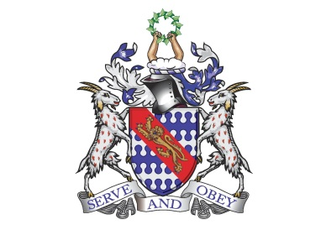
Bunbury Aldersey CE Primary School
My homework tasks for this half term
Autumn 1
Spellings to learn
Below are the words children are expected to be able to spell by the end of year 1. The spellings for homework will remain the same all year. Whilst we will be continuing to follow the weeks below at school, please feel free to work on the words unknown to your child at home.
Week 1 | Week 2 | Week 3 | Week 4 | Week 5 | Week 6 | Week 7
the  a  do  to  today  of | said  says  are  were  was  is | his  has  I  you  your  they | be  he  me  she  we  no | go  so  by  my  here  there | where  love  come  some  one  once | ask  friend  school  put  push  pull
Additional Spellings (if needed):

Monday, Tuesday, Wednesday, Thursday, Friday, Saturday, Sunday

One, two, three, four, five, six, seven, eight, nine, ten.
Maths
Count to and across to 20, forwards and backwards, beginning with 0 or 1, or from any given number.
This objective can be practiced in a variety of ways. Here are some ideas:
- Verbal counting.
- Verbal counting – shout the odd and whisper the even numbers.
- Board games. Card games with numbers.
Number Bonds to 10, then 20.
This objective can be practiced in a variety of ways. Here are some ideas:
- Finding number pairs (cards) to make 10, or 20
- Verbally counting from a certain number up, e.g starting from 6, how many more to reach 10?
- Using objects to make 10, then 20.
Recognise 2D and 3D shapes
This objective can be practiced in a variety of ways. Here are some ideas:
- Looking at objects in the home and identifying what shape they are.
- Shape hide and seek – ‘can you find the sphere?’
Recommended reading linked to our theme
Penguins (Usborne) by Emily Bone
Zoo-ology by Joelle Jolivet

