Y1 Autumn A Takeaway Homework
Choose one task and bring your work into school for sharing on Wednesday 22nd October.
Science - Seasons  Complete an autumn walk – what common and wild plants can you find and name, including trees. What do you notice? What is changing with the season?  Take some photos and chose a way to present what you have found. | History – ask questions about the past  Create a family tree. Where did your family live?  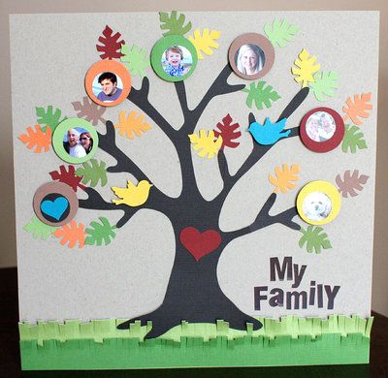 | D&T - Create a home for the penguin.  What will the penguin need to survive? What resources will you need?  You can present this as an image, or by making a miniature model of the home!  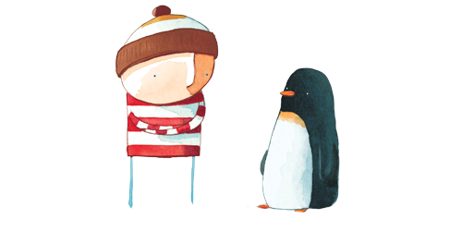
Geography  Chose one capital city in the United Kingdom and create a fact file about it. You can present this in any way that you wish.   | Art  Create your own penguin-themed piece of art. This could be a collage, a painting, a model – anything you choose! | Computing  Internet Safety!  Can you choose a way to teach others about how to be safe on the internet? You may like to record a video of all the important things you know!

