
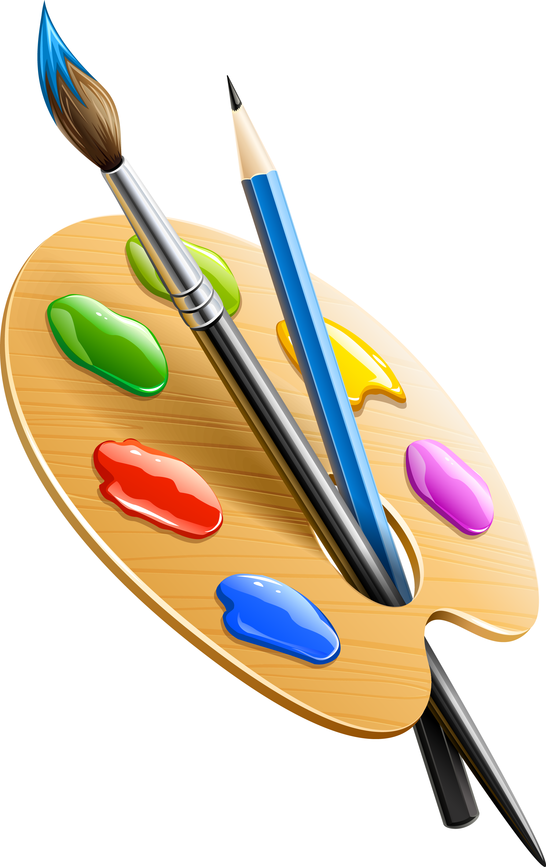
BUNBURY ALDERSEY CE PRIMARY AND NURSERY SCHOOL
EYFS – Expressive Arts and Design
 | Two’s  Autumn | Two’s  Spring | Two’s  Summer
Narrative Play | Start to develop pretend play. For example, a child puts a phone to her ear and talks.
 | - Children generally start to understand the difference between pretend and real from around the age of 2.  - Role play home area – familiar resources and real life objects for children to play with.  - Provide containers and cupboards, transporters and anything else for schemas in the setting. | - Story props and rhyme props to use alongside some books and nursery rhymes.  - Include I’m a little teapot (tea set), Baa baa black sheep (farm set with wool and a master, dame and little boy), and twinkle twinkle (stars, shiny and sparkly objects to play and explore, black cloth)  - Role play – home corner with a new challenge each week including cleaning, washing and sorting clothes, feeding a pet, | - Story props and rhyme props available in reading area for familiar books and whymes. Encourage children to use and play them. Model saying the rhymes or story and selecting the correct resource.  - Story stones and spoons – out them in order and tell a story or rhyme. Encourage children to try or select stones/spoons to decide what is happening next.  - Role Play – Library and shop (1/2 term each) Show children how to play and visit these places, pointing out the roles of people and what is on the shelves. Imitate this in the room. Play alongside and model with adults in the room, directing children where necessary.
Sound and Music | Show attention to sounds and music.  Explore their voices and enjoy making sounds.  Anticipate phrases and actions in rhymes and songs, like ‘Peepo’.  Join in with songs and rhymes, making some sounds.
 | - Introduce children to songs, including songs to go with routines. Suggestion: when washing hands, sing “This is the ways we wash our hands…”. | - Sing songs regularly so that children learn the words, melody and actions off by heart.  - Join in with familiar rhymes, saying words or phrases.  - Copy making sounds from adults and other sources by using listening games, sound walks and what’s in the bag. | - Listen and respond games – when you hear the bell, crouch down. When you hear the drum, jump.  - Find the (instrument) and play. Can stop when instructed.
Dance and Movement | Respond emotionally and physically to music when it changes.  Move and dance to music.
 | - Provide babies, toddlers and young children with a range of different types of singing, sounds and music from diverse cultures. Music and singing can be live as well as pre-recorded. | - Nod head or move feet/hands when listening to music.  - Ask children to choose what they listen to from a selection (have on cards or on wall for children to select as well as verbally).  - Write dance sessions | - Rhythm sessions  - Movement songs such as heads, shoulders, knees and toes and dingle dangle scarecrow.  - Play music and allow children to run abound the hall, freely moving and enjoying it.
Art and Design | Start to make marks intentionally.  Explore paint. Using fingers and other parts of their bodies as well brushes and other tools.
 | - Stimulate toddlers' early interest in making marks.  - Offer a wide range of different materials and encourage children to make marks in different ways. Suggestions: - invite them to submerge their fingers in cornflour - play with a stick in the mud | - Offer a wide range of different materials and encourage children to make marks in different ways. Suggestions: - Place hands and feet in paint and explore making marks on paper for the children to see what they have created and to promote a sense of pride – children to then take these home.  - Make marks in different surfaces using different tools such as in dough. | - Write dance sessions  - Provide sheets of characters of interest (such as Peppa or Bing) for children to mark make on. Can you colour his hat? Can we draw him some boots? Praise and encourage all mark making.  - Explore paint with a variety of tools including sponges, toothbrushes, cotton wool, toys, sticks, fingers and stamps.
Design Technology | Explore different material, using all their senses to investigate them. Manipulate and play with different materials.
 | - Stimulate young children’s interest in modelling. Suggestions: provide a wide range of found materials (‘junk’) as well as blocks, clay, soft wood, card, off cuts of fabrics and materials with different textures.  - Explore making bird feeders using recycled bottles and put in the outdoor environment for children to see how they are used. | - Explore gloop, slime, wet sand, dry sand, water beads, shaving foam, dough, dry and wet mud using all senses. Add scents, textures and hidden objects for children to explore.  Use lots of language modelling and introduce new nouns and adjectives. | - Explore playing with food (wet and dry) using senses.  - Explore textured paint (add shaving foam, sand, glitter, washing up liquid)  - Explore bubble wrap, foil, tissue paper, stickers, corrugated card.

