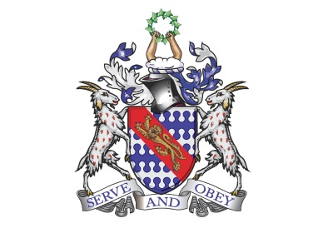

**Bunbury Aldersey CE Primary School**

**My homework tasks for this half term – Summer B**

**High frequency word spellings to learn**

|  |  |  |  |  |  |  |
| --- | --- | --- | --- | --- | --- | --- |
| **Week 1** | **Week 2** | **Week 3** | **Week 4** | **Week 5** | **Week 6** | **Week 7** |
| **marvellous**  **mischievous**  **muscle**  **necessary**  **neighbour**  **nuisance**  **occupy**  **occur** | **opportunity**  **parliament**  **persuade**  **physical**  **prejudice**  **privilege**  **profession**  **programme** | **pronunciation**  **queue**  **recognise**  **recommend**  **relevant**  **restaurant**  **rhyme**  **rhythm** | **sacrifice**  **secretary**  **shoulder**  **signature**  **sincerely**  **soldier**  **stomach**  **sufficient** | **suggest**  **symbol**  **system**  **temperature**  **thorough**  **twelfth**  **variety**  **vegetable** | **vehicle**  **yacht**  **accommodate**  **accompany**  **according**  **achieve**  **aggressive**  **amateur** | **Consolidate any tricky spellings from the list** |

**Times tables / division to learn**

|  |
| --- |
| **Please learn all times tables up to 12 and the related division facts.** |

**Recommended reading linked to our topic**

|  |
| --- |
| **Smart About Sharks by Owen Davey**  **Atlas of Ocean Adventures by Emily Hawkins & Lucy Letherland**  **Interview with a Shark by Andy Seed & Nick East**  **This Morning I Met a Whale by Michael Morpurgo & Christian Birmingham**  **Shark Lady by Jess Keating & Marta Alvarez Miguens**  **Curious Creatures Glowing in the Dark by Zoe Armstrong & Anja Susan**  **The Lost Whale by Hannah Gold & Levi Pinfold**  **Malamander by Thomas Taylor**  **Ariki and the Giant Shark by Nicola Davies & Nicola Kinnear**  **Song of the Dolphin Boy by Elizabeth Laird & Peter Bailey**  **The Girl Who Thought Her Mother Was a Mermaid by Tania Unsworth**  **The Aquanaut by Dan Sentat**  **The Brilliant Deep: Rebuilding the World’s Coral Reefs by Kate Messner & Matthew Forsythe**  **Oceanarium by Loveday Trinick & Teagan White**  **Earth’s Incredible Oceans by Jess French & Claire McElfatrick**  **Blue Planet II by Leisa Stewart-Sharpe & Emily Dove** |