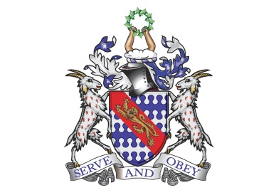

**Bunbury Aldersey CE Primary School**

**My homework tasks for this half term**

**Summer 2**

**Spellings to learn**

Below are the words children are expected to be able to spell by the end of year 1***. The spellings for homework will remain the same all year***. The children are beginning to confidently spell many of these words now. Whilst we will be continuing to follow the weeks below at school, please feel free to work on the words unknown to your child at home.

|  |  |  |  |  |
| --- | --- | --- | --- | --- |
| **Week 1** | **Week 2** | **Week 3** | **Week 4** | **Week 5** |
| full  pull  where  there  were  here | of  says  said  are  love  ask | friend  school  house  our  push | you  your  they  one  once | said  was  come  some |
| **Additional Spellings (if needed):**  Monday, Tuesday, Wednesday, Thursday, Friday, Saturday, Sunday  One, two, three, four, five, six, seven , eight, nine, ten. | | | | |

**Maths**

|  |
| --- |
| **Volume and Capacity; comparing and finding capacity**  This objective can be practiced in a variety of ways. Here are some ideas:   * Talking about containers for products at home * Measuring and creating potions * Creating games by filling to set amounts: full, half full   **Mass; measuring and comparing using lighter and heavier**  This objective can be practiced in a variety of ways. Here are some ideas:   * Cooking and following recipes * Looking at the mass of existing products   **Money; recognising notes and coins**  This objective can be practiced in a variety of ways. Here are some ideas:   * Matching/snap games with coins and their amounts * Looking at the costs of items in shop, what coins can pay for this?   **We will also be recapping many of our previously covered units in Maths** |

**Recommended reading linked to our theme**

|  |
| --- |
|  |