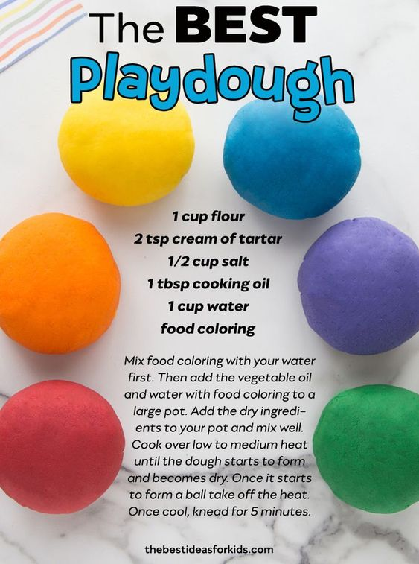

2 cups of flour

3 tsp cream of tartar

1 cup of salt

2 tbsp cooking oil

2 cups of water

Food colouring