CHRISTMAS HOMEWORK! due anytime first week back!

This half term the children have been learning about different fairy stories. They have really enjoyed writing their own stories. They now hang from our story tree!
This last week we have been looking at the artist Carl Warner for inspiration when describing the witches’ house in Hansel and Gretel. He uses food to create different landscapes. I have put some of his pictures on the web page.
Here are our two favourites.
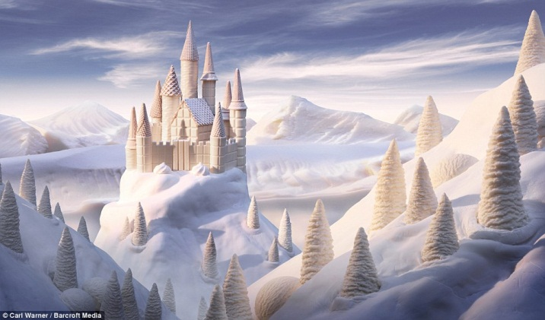 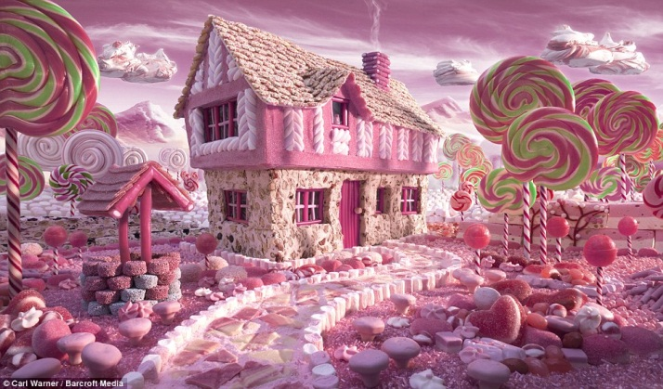
Your challenge is to create your own fairy-tale house. It can be made out of anything you want! Maybe you will have cornflake roof or marshmellow walls! It can be done in any way you want. You can use photos of different foods or draw and colour them in. You could even use some real sweets if you want! It doesn’t have to be a 3d gingerbread house!
I will put a template on the class page in case you want to use it…you don’t have to!
When you come back after Christmas you can present your work!

Merry Christmas and a Happy New Year!
Love Mrs Moxley

