On July 20th 1969, Neil Armstrong clambered down the ladder of the lunar module Eagle and became the first human being to stand on the surface of the moon. The History News gave a glowing report of this monumental milestone in the history of space exploration.
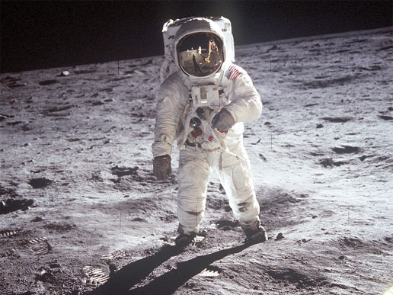
Figure 1: Edwin 'Buzz'Aldrin on the moon

Mesmerised, one-fifth of the entire population of the world watched TV in wonder as American astronaut Neil Armstrong stepped on to the surface of the Moon.
On 16th July, three men left Earth in their space capsule Apollo 11, thrust into space by its awesomely powerful Saturn 5 rocket. Four days later, the astronauts arrived at their destination – the Moon!
“That’s one small step for man, one giant leap for mankind,” his voice echoed round mission control in Houston, Texas, 384,000 kilometres away.
A few seconds later, Armstrong was joined on the surface by Edwin ‘Buzz’ Aldrin. The third member of the crew, Michael Collins, was still in orbit around the Moon. He had remained in Apollo 11’s command module Columbia.

Armstrong and Aldrin explored the area of the moon where they had landed before they proudly erected a US flag with a special wire frame to hold it (as there is no wind on the Moon). Then they collected samples of the rocks that litter the Moon’s landscape to take back for analysis at a laboratory on Earth.
After completing their tasks, the pair returned to Eagle, ignited the engine and headed for their rendezvous in space with Columbia.
The United States have now fulfilled the first part of President Kennedy’s promise – to land a man on the moon – now they need to accomplish the second, to return him safely to Earth.

