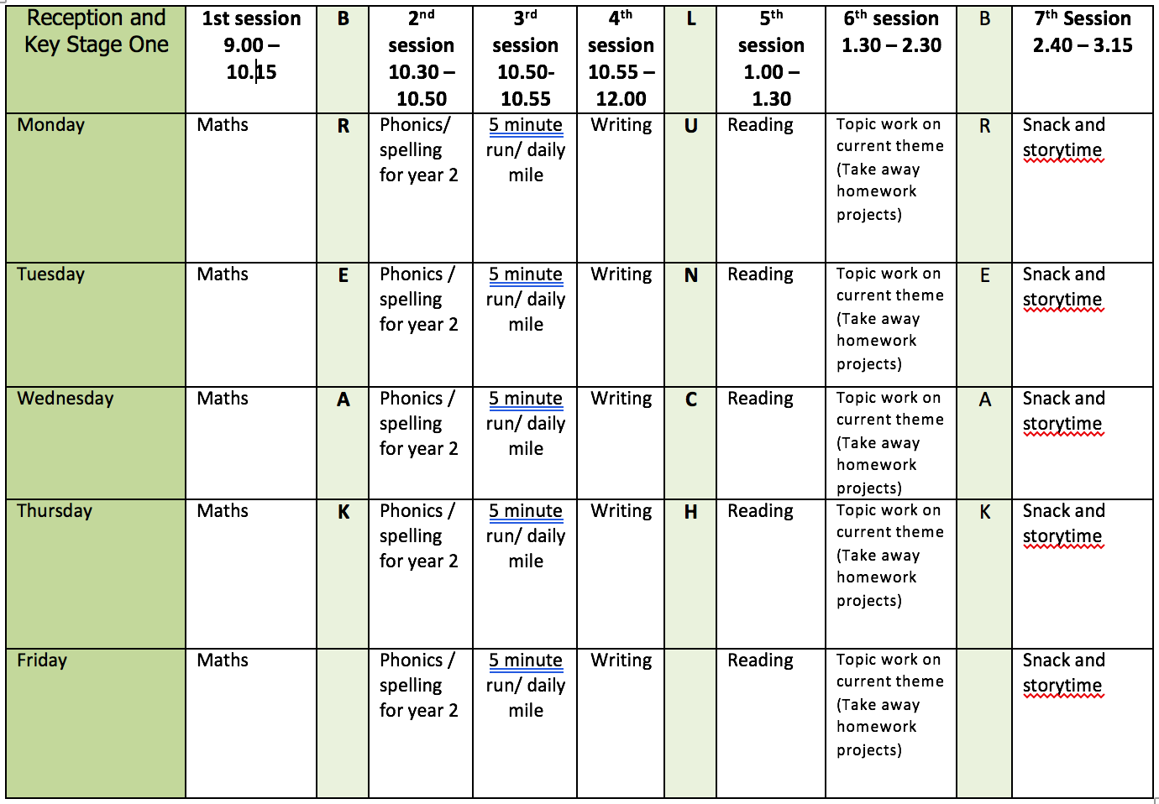

ENGLISH WRITING: Instructions
Resource sheets for each lesson are on the webpage.
Monday
- Packing Up – write instructions for packing one of the items on the activity sheet.
Tuesday
- Good Enough To Eat – Use the example of Giant Egg Rolls. Write out and illustrate your favourite recipe for a Y2 class recipe book. Keep your recipe until we return to school, post to me at school or post on Padlet.
Wednesday
- Good Enough To Eat – use the ideas on the activity sheet to invent A Revolting Recipe To Delight a Dreadful Dragon.
Thursday
- How To Make… – write a set of instructions for how to make something or how to play a game. Use the example of making a papier-mache globe to help you.
Friday
- Better Instructions – improve the instructions for making toast.

Further resources to help with writing instructions:
- BBC Bitesize Writing Instructions https://www.bbc.co.uk/bitesize/topics/zpbbkqt/articles/zbv72sg
- BBC Bitesize Writing Commands https://www.bbc.co.uk/bitesize/topics/zrqqtfr/articles/z8strwx

READING
For list of comprehension questions about texts refer to the school document ‘Supporting Reading At Home’ document or use the questions on the reading bookmark given earlier in the year.
Monday
- Fluency Expression - reading out loud to develop reading fluency and expression. Continue this daily throughout the week. Use the 20 Books to Read in 2020 to record different books you read.
Tuesday
- Oral Comprehension Questions – parent/carer to use the list of questions ‘Supporting Reading At Home’ or the questions on the Reading Bookmark.
Wednesday
- Word Recognition - practice reading the words from the Y1 & Y2 lists or Y3/4 if you can read all the Y1 & Y2 words.
Thursday
- Find 5 interesting words in a book you are reading. Write down the meaning of each word and then use each one in a sentence of your own.
Friday
- Book Review - Give a book you have read this week marks out of ten and explain why you gave it this mark. Put your review on Padlet for others to read.

Further resources to help with reading:
- Literacy Shed Reading Comprehension Packs- Additional Packs at https://www.literacyshedplus.com/en-gb/browse/free-resources/reading-comprehension-plus
- KS1 Reading Comprehension Tests – past papers can be downloaded at https://www.gov.uk/government/collections/national-curriculum-assessments-practice-materials - key-stage-1-past-papers
- Oxford Owl For Home
https://www.oxfordowl.co.uk/?open_loginbox=true?selLanguage=en&mode=hub
- Book Scavenger Hunt
- 40 Book Based Activities
- 20 Books to Read for 2020

SPELLING
When practising spelling use the ideas in the school booklet ‘Help You Child with Spelling’.
With the dictation passage parent/carer to dictate sentences one at a time. Check spelling and punctuation in these sentences.
Monday
- Spelling AY words – play, pay, say, stay, day, today, holiday, way, away, may
- Spelling - days of the week
- Dictation - On Tuesday Jim will go away on holiday. Sam will stay at home and play with his dog. He cannot pay for a holiday.
Tuesday
- Spelling AI words – rain, train, rail, tail, snail, pain, paint, wait
- Dictation - Sam waits for the train in the rain. He has a pain in his bad foot. Jim will ride home in his big red car. Sam feels cross as he waits for the train.

Wednesday
- Spelling A-E words – cake, case, game, gate, made, name, plane, shape, snake, save, plate
- Dictation - Sam made a big cake in the shape of a snake. He will save the cake for Jim. Jim is thin.

Thursday
- /n/ sound spelt kn and gn at the beginning of words
- Word list – knock, know, knee, knit/knitting, knife, gnat, gnaw, gnome, gnarled
- Interesting fact - the ‘k’ and ‘g’ at the beginning of these words was sounded hundreds of years ago.
Friday
- Use the words lists on the webpage. Look for any of this week’s sound/spelling focus on these lists and practice spelling them.
- If there aren’t any choose a selection of words to learn and write in a sentence.

Further resources to support Phonics and Spelling:
- Word Lists – Y1, Y2, Y3/4
- Help Your Child With Spelling Document
- Read Write Inc. – daily phonics/spelling lesson starting at 9.30 and then available for 24 hours after that https://www.youtube.com/channel/UCo7fbLgY2oA_cFCIg9GdxtQ

MATHEMATICS (WHITE ROSE)
All these resources are on the webpage with the exception of Friday.
Monday
- Lesson 1 The 10 times-table
Tuesday
- Lesson 2 - Make equal groups (sharing)
Wednesday
- Lesson 3 -Make equal groups (grouping)
Thursday
- Lesson 4 Odd and Even Numbers
Friday
- Friday Maths Challenge - White Rose in partnership with BBC Bitesize https://www.bbc.co.uk/bitesize/tags/z7s22sg/year-2-and-p3-lessons/1

Further resources to support mathematics:
- Times Table Rockstars https://ttrockstars.com
- Purple Mash https://www.purplemash.com/sch/bunburyaldersey
- Mathletics https://login.mathletics.com

TOPIC/WELL BEING WORK

Monday
- Well Being Activity - Using shapes to help breathing.
- Look at the activity sheet for ideas or use your own e.g. hand shape, leaf

Tuesday
- BBC Bitesize Introduction To Materials https://www.bbc.co.uk/bitesize/articles/z6kdwty
- Stem Video – Materials https://stemlearning.wistia.com/medias/bntxirwlau
- Answer Questions 1-6 on the STEM worksheet, leave the challenges until Wednesday/Thursday.

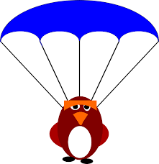
Wednesday
- Challenge 1 – Crash Landing?
- What property does a material need if you want to make a parachute?
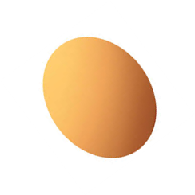
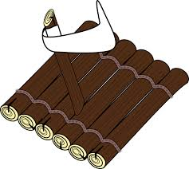
- Choose an object such as a Lego person, or a ball of playdough and make a parachute for it from a material you choose. You want the parachute to float slowly to the ground when you drop it. You’ll need to think about why the material you choose is suitable. You could test a few different ones to compare them!

Thursday
- Challenge 2 – Egg Passenger

- Can you make a raft that will float in a bowl of water… and stop an egg from sinking? What properties will the materials need? If you don’t have any eggs, choose a different object to test your raft with.
- You’ll need to think about why the material that you’re going to use is suitable – you could test a few different rafts to compare them!

Friday
- What Can You Do With a Button? Different ways of sewing a button. See ideas sheet on sheet provided. E.g. picture, different ways of sewing a button

PHYSICAL EDUCATION
- Use the links and resources from Mr Dooley already available on the class home learning webpage
- PE with Joe https://www.youtube.com/channel/UCAxW1XT0iEJo0TYlRfn6rYQ
- Go Noodle Activities https://family.gonoodle.com

