Year 4
WB 1.6.2020

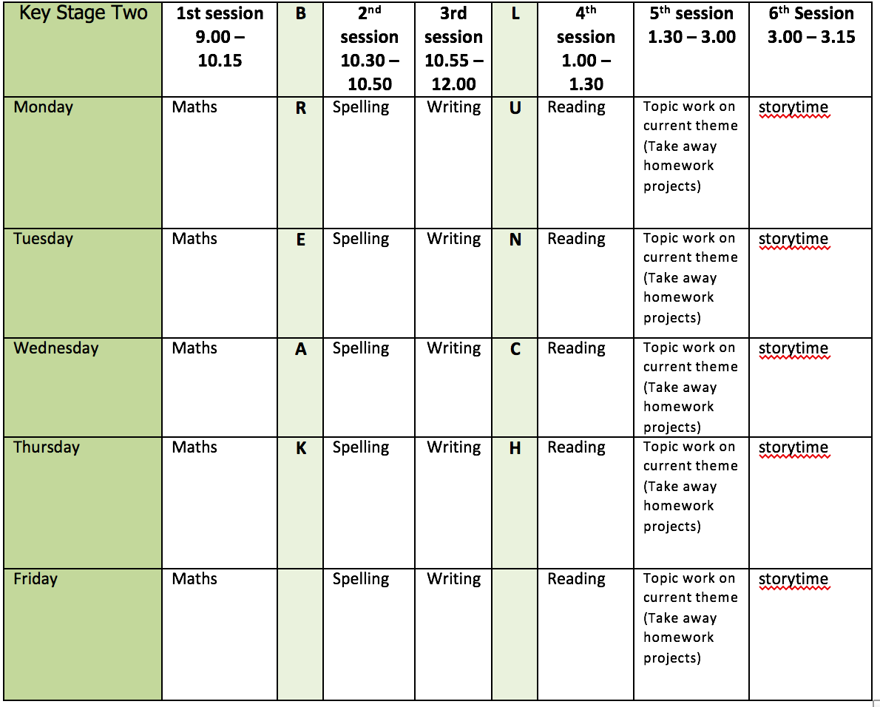
Mental health and well being
Cosmic Kids Yoga – there are some new ones on their YouTube that we haven’t tried in school:
https://www.youtube.com/user/CosmicKidsYoga/videos

English writing activities for the week: Explanation text on ‘The Water Cycle’
1. Research ‘The Water Cycle’ – what happens? See below for useful weblinks and activities:
https://www.bbc.co.uk/bitesize/topics/zkgg87h/articles/z3wpp39
https://www.unitedutilities.com/globalassets/documents/pdf/uu-education-booklet-spreads.pdf
2. Create a storyboard of The Water Cycle – see below example
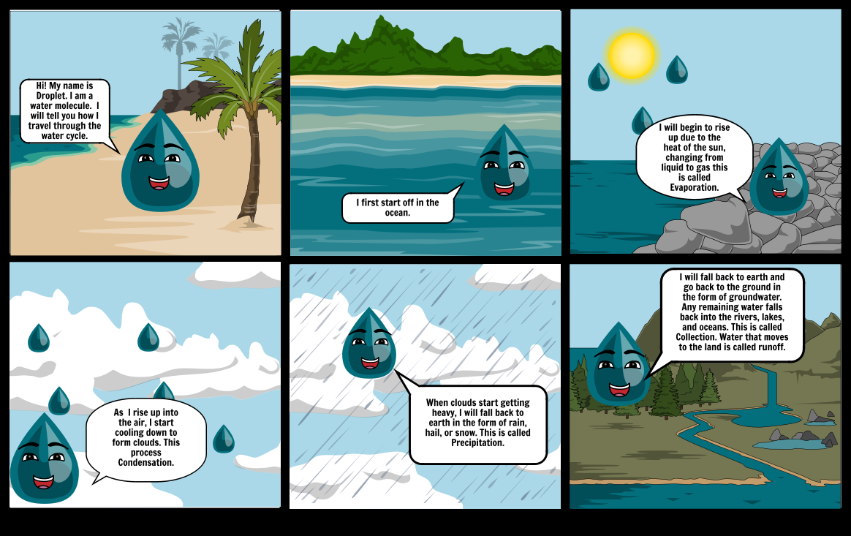
3. Identify all of the technical vocabulary you will need to write about The Water Cycle. Practise spelling it and writing it in your neatest cursive handwriting.
4. Plan and write the Introduction paragraph to your explanation text about The Water Cycle – remember this needs to introduce the topic and give a brief overview but NOT explain anything yet! Don’t forget to proof-read and make any corrections.
5. Plan and write the first Point which will be about evaporation. Don’t forget to proof-read and make any corrections.

Reading:
3 days on Pugs of the Frozen North comprehension (4 questions each day, extra activities at bottom if needed), 2 days reading for pleasure.

Spelling:
Suffix ‘ous’ e.g. famous, furious, various, poisonous, dangerous, mountainous, courageous, spacious (2 days)
Continue practise of words from Y3/4 list (3 days)

Maths activities for the week:
All worksheets and video links available on White Rose maths tab
1. Add 2 or more fractions
2. Subtract 2 fractions
3. Fractions of a quantity
4. Calculate quantities
5. Revision of anything tricky from week/Mathletics/Times Tables Rock Stars/Purple Mash maths games

Topic work
1. Read about 4-figure grid references here:
https://www.bbc.co.uk/bitesize/guides/z6j6fg8/revision/4
Or watch Steve Backshall (he’s much better than me!) explain:
https://youtu.be/c0du8v4EE_Y
Then have a go at this game to see if you have understood! http://resources.hwb.wales.gov.uk/VTC/grid_refs/eng/Activity/default.htm
Do you have any maps in your house that use 4-figure grid references? If so, have a look at them.
2. Head out on a walk around your local area with a grown up. How many different human (e.g. canal, house, bridge) and physical (e.g. river, hill, forest) features can you spot? Make a list of these features.
3. Create a map of the area you studied on your walk. Add grid references and a key.
4. Create a quiz for someone else in your house based on your map. Make sure to challenge them with some 4-figure grid reference questions!
5. Have a go at this challenge: https://www.geographyalltheway.com/wp-content/uploads/11-14/maps-atlases/four_fig_grid_ref.pdf

PE
This week’s challenge – complete a Go Noodle video each day!
https://www.youtube.com/user/GoNoodleGames
Banana, Banana, Meatball is my personal favourite (sorry grown ups!)

