Materials – their uses and properties
Name: _______________________________
As you work through the video, press pause to enable you to think, join in, try some of the activities, and write the answers on this worksheet. You will then be able to take it back into school to show your teacher!

- Can you write names of objects that could be made from the following materials? The first one has been done for you!

Material | Object made from material
Wood | Tree
Plastic

Metal

Brick

Cardboard

- Go to this website: https://www.bbc.co.uk/bitesize/topics/zrssgk7/articles/z9pgcdm
Click on the objects in the picture to find out what material they’re made from and why. Watch some of the videos and see what you can find out!

- Try this website, and see what else you can find out about types of materials: https://www.bbc.co.uk/bitesize/topics/z4339j6/articles/zx8hhv4

What have you found out so far?

- Listen to the song about the properties of materials on this website – and they we use materials with certain properties to make different objects: https://www.youtube.com/watch?v=xOKr462HLc0

- Can you match the word with its definition? One of them has been done for you!

This tells us how a material looks, feels or behaves when we use a force on it
object

This describes how an object goes back to its original shape after it has been stretched
material

This is name for what the object is made out of – they include plastic, metal, wood….
property

Another name for a “thing”
elastic

- Explore materials further using these websites:
https://www.stem.org.uk/primary-science
https://www.bbc.co.uk/bitesize/topics/zrssgk7
https://www.bbc.co.uk/bitesize/topics/zryycdm

Are you ready for a Challenge?
Why not try the Challenges below – we’d love to see your attempts on Twitter – tag us @NwySlp and we will comment back!
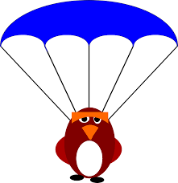
Challenge 1 – Crash Landing?
What properties does a material need if you want to make a parachute?
Choose an object such as a Lego person, or a ball of playdough and make a parachute for it from a material you choose. You want the parachute to float slowly to the ground when you drop it. You’ll need to think about why the material you choose is suitable. You could test a few different ones to compare them!

How did you get on? Upload your photo/video onto Twitter – tag us @NwySlp

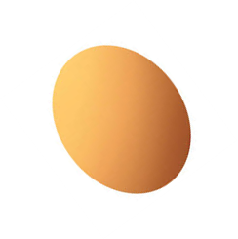
Challenge 2 – Egg Passenger
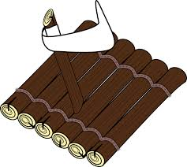
Can you make a raft that will float in a bowl of water… and stop an egg from sinking? What properties will the materials need? If you don’t have any eggs, choose a different object to test your raft with.
You’ll need to think about why the material that you’re going to use is suitable – you could test a few different rafts to compare them!

How did you get on? Upload your photo/video onto Twitter – tag us @NwySlp

