Week beginning: 1.6.20
Year 6
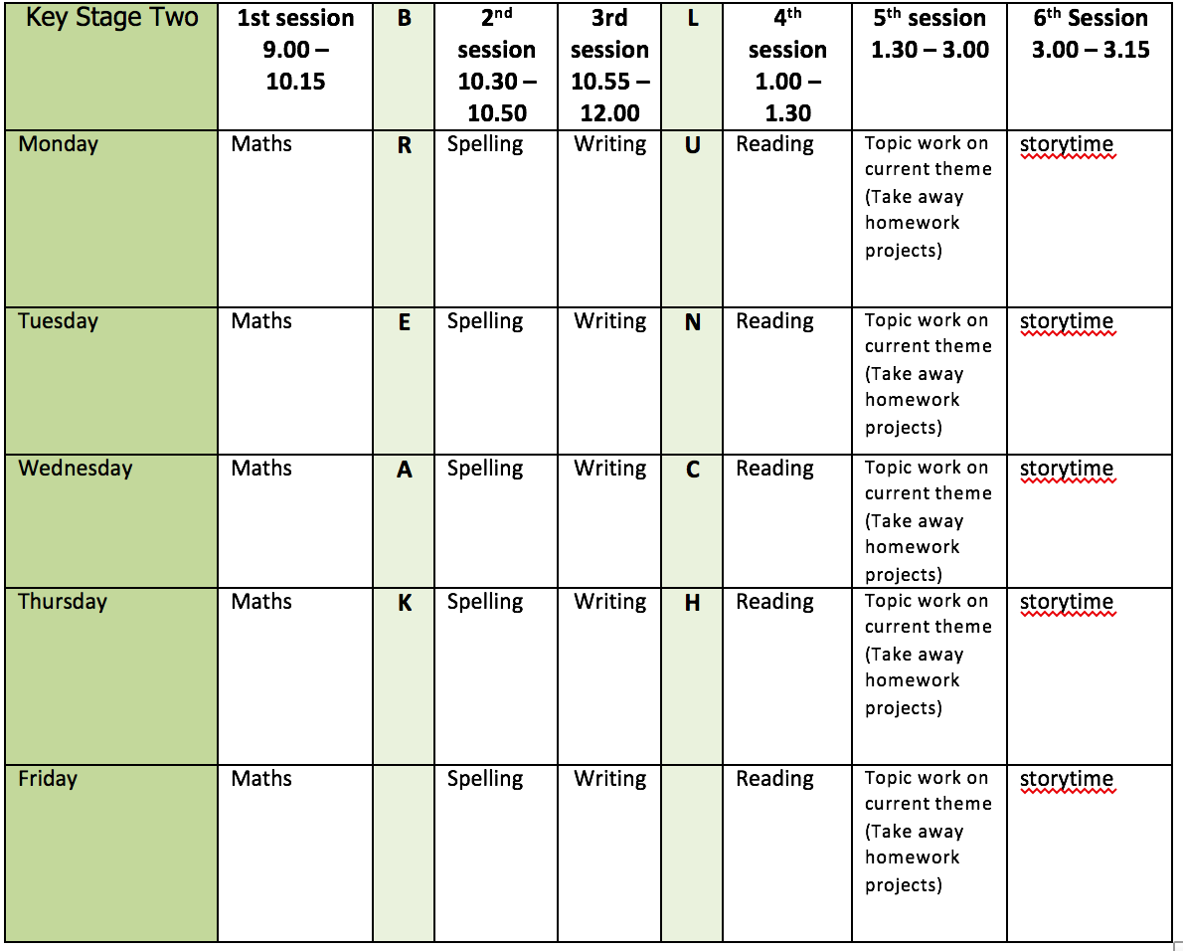
Mental health and well being
Choose an activity from the list below as and when you need it:
1. Colouring sheets.
2. Crosswords
3. Sudoku
4. Doodling/drawing
5. Reading
6. Listen to relaxing music https://www.youtube.com/watch?v=qFZKK7K52uQ
7. Yoga - https://www.youtube.com/watch?v=Td6zFtZPkJ4

Maths activities for the week:
1. Monday Lesson 1 - Fractions to percentages
2. Tuesday Lesson 2 - Equivalent FDP
3. Wednesday Lesson 3 - Order FDP
4. Thursday Lesson 4 - Percentage of an amount
5. Friday Lesson 5 - Practise your timestables (on TT rock stars if you wish) and then complete the appropriate timestable sheet (5 minute timer) Also complete mathletics tasks.

Spelling:
The spelling pattern focus for this week is: able/ible, ably/ibly

Teach tips: able is far more common than ible. The suffix actually means ‘able’ – adorable – able to adore. If the –able ending is added to a word ending in –ce or –ge, the e after the c or g must be kept as those letters would otherwise have their ‘hard’ sounds before the a of the –able ending e.g. changeable, noticeable. The –able ending is usually but not always used if a complete root word can be heard before it, even if there is no related word ending in –ation. For example: understandable, reliable. However, in reliable, the complete word rely is heard, but the y changes to i in accordance with the rule.
The –ible ending is common if a complete root word can’t be heard (e.g. horrible) before it but it also sometimes occurs when a complete word can be heard (e.g. sensible).

1. Monday - Create a table with different able/ible ably/ibly words in. Highlight the endings and think about why it has that particular ending.
2. Tuesday - Choose of the 3 words where the meaning is not known. Look them up in a dictionary.
3. Wednesday - Create 5 sentences using the words.
4. Thursday - Learn the able/ible ably/ibly words. (Use different colours, write mnemonics to remember the letter order, draw around the shape of the word, play hangman, test yourself)
5. Friday - Complete the wordsearch.

English writing activities for the week: Journalistic writing (newspaper report)
Hopefully, you have had an enjoyable water fight by now (if not, you can still pretend you did!)
1. Monday. First, look at any photos or videos of your water fight (the ones I have seen have been brilliant!) Then, write down as many key facts of the event as you can (remember the 5ws: when, where, who, what, why). You can explain about not being able to do it at school due to lockdown etc.
2. Tuesday. Read the example newspaper report about Neil Armstrong landing on the moon. Highlight any phrases and punctuation which can be used in your own piece of writing. Interview someone who was involved in your water fight about it and write a quote from them in direct speech – remember to use speech marks. Challenge: can you include indirect speech from a second person? You can make these up if you want to – you could even make up a quote from me!
3. Wednesday. Plan your newspaper report (5ws paragraph, a paragraph which gives more detail, a paragraph which includes quotes and a final paragraph – remember the final paragraph is in present tense). You can include a photo and a caption if you can!
4. Thursday. Write the 5ws paragraph and the paragraph which gives more detail.
5. Friday. Write the quotes paragraph and the final paragraph (remember present tense).

Reading:
1. Monday - 30 mins of independent reading
2. Tuesday - Comprehension (complete the retrieval and inference questions - this week’s is extract 1: The Mystery of the Colour Thief)
3. Wednesday - 30 mins of independent reading
4. Thursday –Comprehension (complete the choice and challenge questions on The Mystery of the Colour Thief)
5. Friday – 30 mins of independent reading

Topic work:
1. Monday DT - Design an ocean friendly product. Options: Ocean friendly sportswear. Ocean friendly drinks bottle. Ocean friendly take away packaging. Your own ocean friendly product idea.
2. Tuesday Music – listen to the sounds of the ocean https://www.bbc.co.uk/programmes/articles/34j4WPCGZnFJvj2Xq9NGK7M/creating-an-underwater-soundscape can you create 1 or more of these sounds using household items, your voice, a music instrument you play?
3. Wednesday Science – electricity introduction. Watch the videos and have a go at the interactive questions. https://www.bbc.co.uk/bitesize/topics/zq99q6f/articles/zt8vg82 and https://www.bbc.co.uk/bitesize/topics/zq99q6f/articles/zs7g4j6
4. Thursday Geography – take a virtual tour of the Great Barrier Reef using airpano.com Create a PowerPoint on the Great Barrier Reef. (complete half this week and you will finish the rest next week) Include: what is it? Where is it? Why is it important? How is it affected by plastic pollution? Photos/maps?
5. Friday Free choice from the takeaway homework list or a mental health and well-being activity.

PE:
Please find ideas for daily PE activities via the link below
https://homelearning.primarypepassport.co.uk/#/
This week’s daily challenge: how many star jumps can you do in 2 minutes? Can you improve your score each day?

