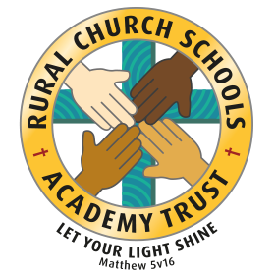

**Individual Liberty:**

Pupil voice surveys where children are asked to respond and reflect on teaching and learning across different topics and subjects.

Choosing takeaway homework

Choices around participation in extra-curricular activities

Responsibilities – corridor monitors, team points, sports ambassadors, maths champion.

School ethos

Young Leaders Award

British Values at Bunbury Aldersey CE Primary School

**Democracy:**

Pupils influence school life through school council

Vote for school the two council members from each year group reflects our British electoral system and demonstrates democracy in action: candidates make speeches, pupils consider characteristics important for an elected representative, pupils vote

Children vote for the rights associated with their Class Charter at the beginning of each school year. All children contribute.

Applications, interviews and vote for Head boy/girl and Deputy boy/girl

Decision-making/voting – dragons den finalists

Election Day and mock voting

**The Rule of the Law:**

Links with Community Police Officers – presence at school to raise the profile of parking safely.

Visits from authorities such as the police and fire service

School rules and each class’ Class Charter, a set of principles that are clearly understood by all and seen to be necessary to ensure that every class member is able to learn in a safe and ordered environment.

Junior Safety Officers

KiVA

Cycling proficiency

During other subjects where there is respect and appreciation for different rules – for example in PE lessons.

**Tolerance of those with different faiths and beliefs:**

Faith days

Festivals, celebrations and traditions from other cultures (taught through our Global topics such as ‘Atlas of Adventures’)

Friday Worship – different religions speakers

Books and resources – cover a wide range of religions and cultures.

**Mutual Respect:**

PHSE

RRSA activities

Celebration assembly

Showing takeaway homework

Buddies

Mission statement encompasses all and is embedded in all aspects of school life: “a caring Christian **family** where we grow together” and “let your light shine”.

Teamwork in residentials

Sporting events

Global and local charities