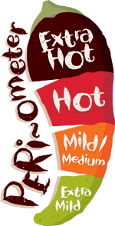
Summer Term (2) 2016
Y6
Take Away Homework!

Choose your homework from the menu below:
The Peri-ometer suggests the difficulty or challenge the homework may offer.
Over the half term try to complete at least three take away tasks (no more than six).
You could challenge yourself and take an option from the ‘EXTRA HOT’ section of the menu!
Bring your work to share on Wednesday 20th July 2016
Create a ‘Wanted’ poster for Lady Macbeth or Macbeth  PSHE/English/topic | Design and make a mask for one of the characters from Macbeth  Art | Design and make a scaled down set in a shoebox for one of the scenes from Macbeth  DT
Create an information leaflet about Scotland for a prospective tourist  Topic/computing | Design and carry out an experiment to explore changes of state  Science | Design and make a model of a witches’ coven, a Scottish castle or a sword.  D.T.
Make some food that could be served at Macbeth’s banquet.  Food tech/Maths | Compose or create some music or sound effects for one of the scenes from Macbeth.  Music | Design a booklet or poster about transition to High School.  PSHE
Find or create a recipe for a smoothie. Upscale the recipe so that it would be suitable for a class of 26 children.  Maths | Find out about the life of Shakespeare and display it in a style of your choice.  History | Choose anything you have been learning about in class and research it more and present it in a form of your choice.  Free choice!

